# Manual Single-Server Build

## Phase 01 Hyper-V Setup and File Structure Build

### Phase Objective

In this phase, you will enable enhanced mode in Hyper-V Manager, create two virtual switches, and build the file structure.

### Phase Topics

In this phase, we will:

* Enable Enhanced Mode in Hyper-V
* Creating Virtual Switches
* Building the File Structure
* Download the ISOs of Server 2016, SharePoint 2016 and SQL Server 2016 to the Created Directories

We use the same file structure for the licensed and evaluation software build, so some folders may be used in one and not the other.

### Enabling Enhanced Mode in Hyper-V

#### Task: Pin Hyper-V Manager to the Task Bar on Your Host PC

*\*Note: there is no PowerShell code block for this task.*

1. Press **Windows** key and enter Hyper.
2. Right-click the **Hyper-V Manager** icon, then click **Pin to taskbar**.

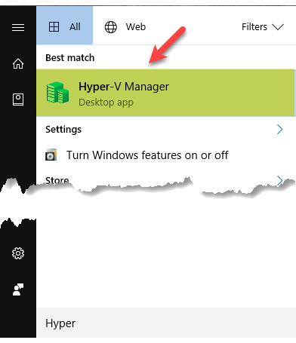

1. Press **Esc** to return to the desktop.

#### Task: Enable Enhanced Mode in Hyper-V

* If you prefer the PowerShell script instructions for this task, click here.

[Set-VMhost -EnableEnhancedSessionMode $TRUE](https://bluebuffalo.sharepoint.com/AmazonRonsNotes/6%20Server%20Farm/Phase%2001%20PS%20Build%20the%20file%20structure.docx)

1. Move down to the taskbar, and start **Hyper V Manager**.
2. When **Hyper-V Manager** opens, review the options available.

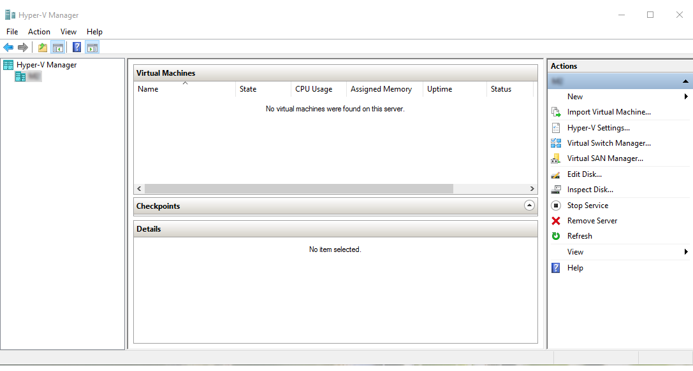

1. Navigate to the pane on the left, right-click the name of the local computer, and click **Hyper-V Settings**.

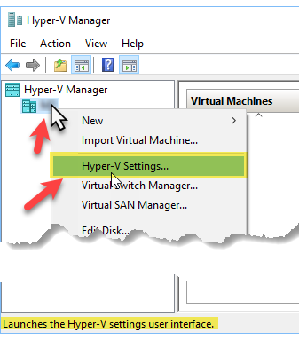

1. When **Hyper-V Settings** opens, move to the pane on the left, locate the **Server** section and click to select **Enhanced Session Mode Policy**.

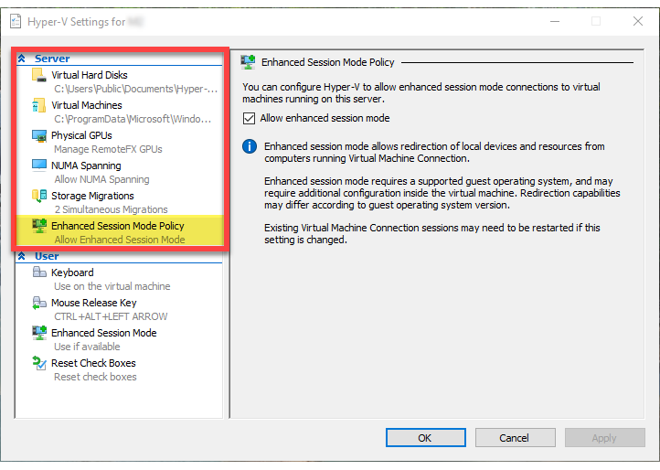

1. Verify there is a check in the **Allow enhanced session mode** check box.

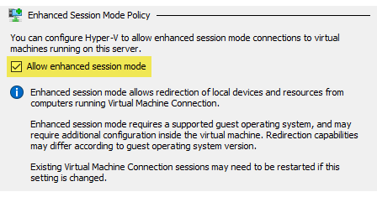

1. If changes were made, click **Apply**.
2. Move to the pane on the left, locate the **User** section and click to select **Enhanced Session Mode Policy**.

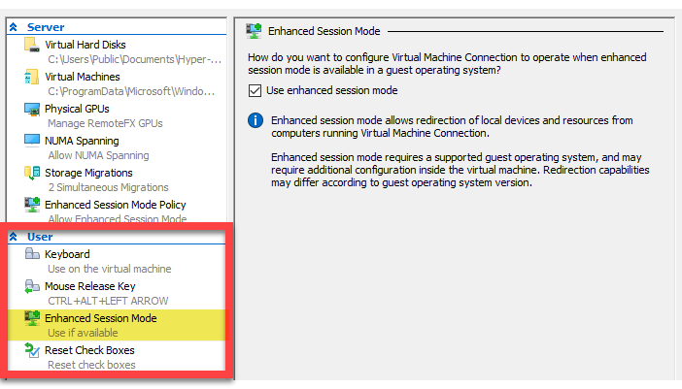

1. Verify there is a check in the **Use enhanced session mode** check box.

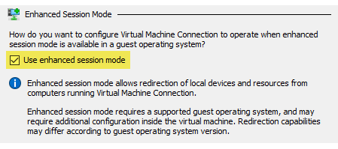

1. If changes were made, click **Apply**.
2. Click **OK**.

### Creating Virtual Switches

Virtual switches provide a way for a virtual machine to connect to a physical network. There are three types:

* External Network
* Internal Network
* Private Network

#### Task: Create Virtual Switches

* If you prefer the PowerShell script instructions for this task, click here.

#TASK: CREATE VIRTUAL SWITCHES

Function Create-vmSwitches{

$ExistSwitchPrivate = get-VMSwitch -SwitchType Private -Name "VMPrivateNetwork" -ErrorAction SilentlyContinue

If (!($ExistSwitchPrivate)) {

New-VMSwitch "VMPrivateNetwork" -SwitchType Private

}

$ExistExternalSwitch = Get-VMSwitch -Name "VMExternalNetwork" -SwitchType External -ErrorAction SilentlyContinue

$ExistExternalSwitch

$NAdapterName = Get-NetAdapter -Physical

If (!($ExistExternalSwitch)) {

New-VMSwitch -Name "VMExternalNetwork" -NetAdapterName $NAdapterName.Name

}}

Create-vmSwitches

1. Navigate to the pane on the left, right-click the name of the local computer, and click **Virtual Switch Manager**.
2. When **Virtual Switch Manager** opens, select **New virtual network switch**.

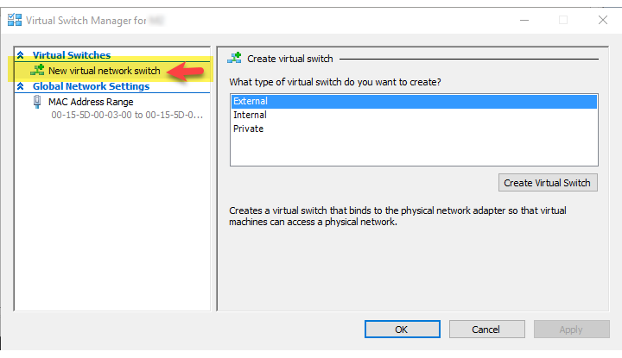

1. Move to the **What type of virtual switch do you want to create** setting and click to select **Private**.
2. Click **Create Virtual Switch**.
3. Move to the **Name** text box and name the switch VMPrivate (or whatever you prefer).
4. Make sure it is connected to the **Private** network.
5. Click **Apply**.
6. Click **OK**.
7. Navigate to the pane on the left, right-click the name of the local computer, and click **Virtual Switch Manager**.

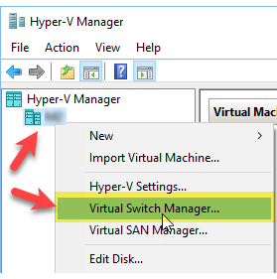

1. When **Virtual Switch Manager** opens, select **New virtual network switch**.



1. Move to the **What type of virtual switch do you want to create** setting and click to select **External**.
2. Click **Create Virtual Switch**.
3. Move to the **Name** text box and name the switch VMExternal (or whatever you prefer).
4. Make sure it is connected to the **External** network, and that your physical Network Interface Card shows in the corresponding setting.
5. Place a check in the **Allow management operating system** **to share this network adapter**.

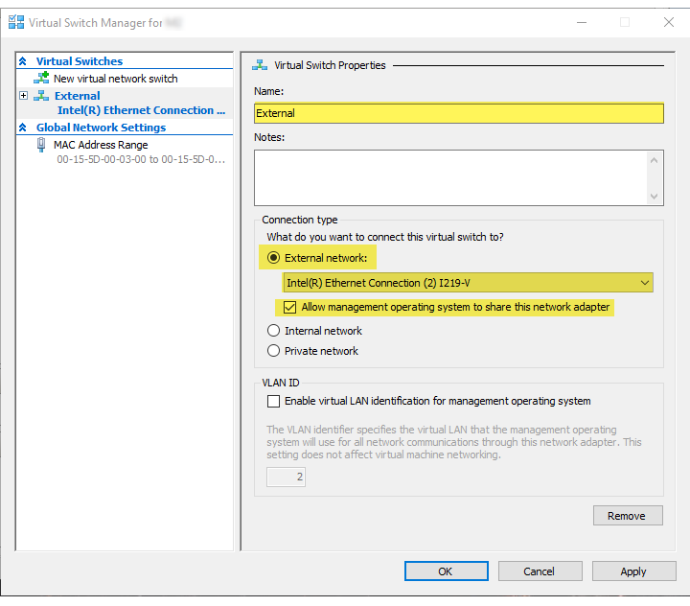

1. Click **Apply**.
2. In the **Apply Networking Changes** dialog box advising **This computer may lose its network connection while the changes are applied**, click **Yes**.

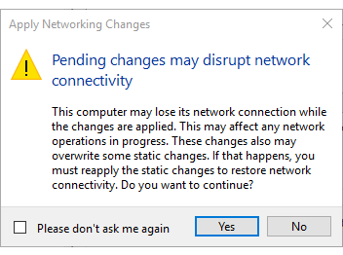

1. Click **OK**.

### Building the File Structure

#### Task: Build the File Structure

* If you prefer the PowerShell script instructions for this task, click here.

#TASK: BUILD THE FILE STRUCTURE

Function Build-FileStructure{

If(!( Test-Path c:\RonsNotes\ISOs\Server2016\)){

New-Item C:\RonsNotes\ISOs\Server2016\ -ItemType directory -ErrorAction SilentlyContinue}

If(!( Test-Path c:\RonsNotes\ISOs\SQL2016\)){

New-Item C:\RonsNotes\ISOs\SQL2016\ -ItemType directory -ErrorAction SilentlyContinue}

If(!( Test-Path c:\RonsNotes\ISOs\Sharepoint2016\)){

New-Item C:\RonsNotes\ISOs\Sharepoint2016\ -ItemType directory -ErrorAction SilentlyContinue}

If(!( Test-Path c:\RonsNotes\Labs\)){

New-Item C:\RonsNotes\Labs\ -ItemType directory -ErrorAction SilentlyContinue}

If(!( Test-Path c:\RonsNotes\Script_Folders\)){

New-Item C:\RonsNotes\Script_Folders\ -ItemType directory -ErrorAction SilentlyContinue}

#Upon completion, File Explorer will be open showing the RonsNotes folder contents.

ii C:\RonsNotes

}

Build-FileStructure

1. Start **File Explorer**.
2. Navigate to **C:/**.
3. Create a new folder and name the folder **RonsNotes**.
4. Double-click to open **RonsNotes** folder, and create three more folders:
   * ISOs
   * Labs
   * Script_Folders
5. Double-click to open **ISOs** folder, and create three more folders:
   * Server2016
   * SharePoint2016
   * SQL2016
6. Back out of the **ISOs** folder, and leave **File Explorer** open.

### Download the ISOs of Server 2016, SharePoint 2016 and SQL Server 2016 to the Created Directories

#### Task: Download the ISOs of Server 2016, SharePoint 2016 and SQL Server 2016 to the Created Directories

*Note: there is no equivalent to this task in PowerShell.*

In this task, we will download ISOs for the software we intend to install.

*SharePoint 2016 comes down as a IMG file not an ISO.*

1. Start **File Explorer**.
2. Navigate to **C:\RonsNotes\ISOs**.
3. Notice you have three folders listed.

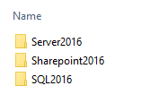

1. Start **Internet Explorer**, or the browser of your choice.
2. Navigate to the below links and download the installation files to the appropriate folder (shown above).

*You will need to register in order to download the required ISO files.*

* + Server 2016 – <https://www.microsoft.com/en-us/evalcenter/evaluate-windows-server-2016>
  + SharePoint 2016 - <https://www.microsoft.com/en-us/evalcenter/evaluate-sharepoint-server-2016>
  + SQL Server 2016 - <https://www.microsoft.com/en-us/evalcenter/evaluate-sql-server-2016>

Upon completion, you will have the file structure built, and the downloaded ISOs placed into the proper locations.

## Phase 02 Create Virtual Machines and Install Server 2016

### Phase Objective

This phase creates the virtual machine. First, we will create the Virtual Hard Drive (VHDX format), then we will install Server 2016. We are assuming you are using evaluation licenses. If not, proceed as is, then at the end, you can just convert to MSDN by changing your keys.

After creating the virtual machine, we will enable Guest Services, then install Server 2016.

### Phase Topics

* Verifying the Correct Files Are in the Proper Location
* Creating Virtual Machines
* Installing Windows Server 2016

### Verifying the Correct Files Are in the Proper Location

#### Task: Verifying the Correct Files Are in the Proper Location

* If you prefer the PowerShell script instructions for this task, click here.

#TASK: VERIFYING THE CORRECT FILES ARE IN THE PROPER LOCATION

Function Test-CorrectFiles {

$ISOSvr2016 = Get-ChildItem C:\RonsNotes\ISOs\Server2016\ | %{$_.Name} -ErrorAction inquire # ASK

$ISOSql = Get-ChildItem C:\RonsNotes\ISOs\SQL2016\ | %{$_.Name} -ErrorAction inquire # ASK

$IMGSharePoint2016 = Get-ChildItem C:\RonsNotes\ISOs\Sharepoint2016\ | %{$_.Name} -ErrorAction inquire # ASK

If ($ISOSvr2016 -eq "14393.0.160715-1616.RS1_RELEASE_SERVER_EVAL_X64FRE_EN-US.ISO")

{Write-Host "Expected version of ISO for Server 2016 in expected location" -ForegroundColor Green}

Else {Write-Host "Wrong or missing Server 2016 ISO. 14393.0.160715-1616.RS1_RELEASE_SERVER_EVAL_X64FRE_EN-US.ISO expected Correct to continue " -ForegroundColor Red; Read-Host -Prompt "Any key to continue" }

If ($ISOSQL -eq "SQLServer2016-x64-ENU.iso")

{Write-Host "Expected version of IMG for SQLServer 2016 in expected location" -ForegroundColor Green}

Else {Write-Host "Wrong or missing SQL 2016 ISO. SQLServer2016-x64-ENU.iso expected. Correct to continue " -ForegroundColor Red ; Read-Host -Prompt "Any key to continue"}

If ($IMGSharePoint2016 -eq "officeserver.img")

{Write-Host "Expected version of IMG for SharePoint Svr 2016 in expected location" -ForegroundColor Green}

Else {Write-Host "Wrong or missing SharePoint.IMG. officeserver.img expected. Correct to continue " -ForegroundColor Red ; Read-Host -Prompt "Any key to continue"}

Write-host "*******"

Write-host "*******"

Write-host "*******"

Write-host "*******"

}

Test-CorrectFiles

1. Switch to **File Explorer**.
2. Navigate to **C:\RonsNotes\ISOs**.
3. Notice you have three folders listed.



1. Verify you have the following file(s) in the corresponding folder.

|  |  |
| --- | --- |
| ***Folder*** | ***File Name*** |
| Server2016 | 14393.0.160715-1616.RS1_RELEASE_SERVER_EVAL_X64FRE_EN-US.ISO |
| SharePoint2016 | officeserver.img |
| SQL2016 | SQLServer2016-x64-ENU.iso |

### Creating the Virtual Machine

We will walk through configuring the virtual machine.

*It is important to note that the finalized folder structures created by Hyper-V Manager will be slightly different if you’ve run the PowerShell script version to create the virtual machines.*

#### Task: Create Humongous Virtual Machine

* If you prefer the PowerShell script instructions for this task, click here.

#TASK: CREATE HUMONGOUS

Function Create-Humongous {

$VMName = "Humongous"

New-VHD -Path "C:\RonsNotes\VM_Drives\Humongus\Humongus.vhdx" -SizeBytes 80GB -Dynamic

New-vm -Name $VMName -MemoryStartupBytes 4GB -VHDPath "C:\RonsNotes\VM_Drives\Humongus\Humongus.vhdx" -BootDevice IDE -SwitchName "VMExternalNetwork"

Set-VMDvdDrive -VMName $VMName -ControllerNumber 1 -ControllerLocation 0 -Path C:\RonsNotes\ISOs\Server2016\14393.0.160715-1616.RS1_RELEASE_SERVER_EVAL_X64FRE_EN-US.ISO

Set-vm $VMName -ProcessorCount 4

Add-VMDvdDrive -VMNAME $VMName -ControllerNumber 1 -ControllerLocation 1 -Path C:\RonsNotes\ISOs\SQL2016\SQLServer2016-x64-ENU.iso

Start-VM $VMName

} #END

Create-Humongous

1. In **Hyper-V Manager**, right-click on the name of your server, and select **New | Virtual Machine…**.

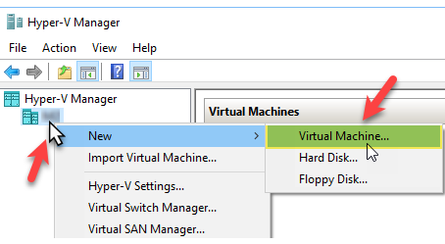

1. When the **New Virtual Machine Wizard** opens, view the message in the **Before You Begin** section, then click **Next**.

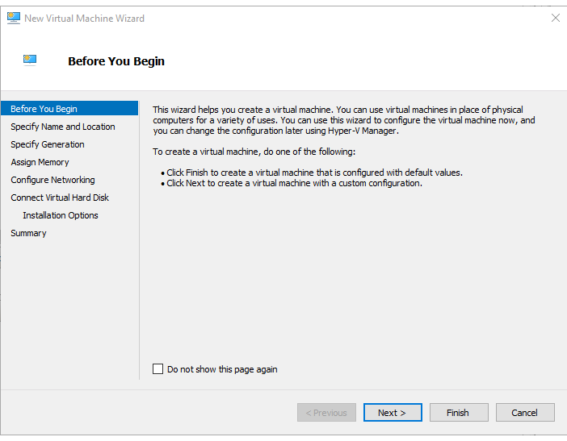

1. Navigate to the **Name** text box and enter Humongous.
2. Place a check in the **Store the virtual machine in a different location** check box.
3. Click the corresponding **Browse…**.

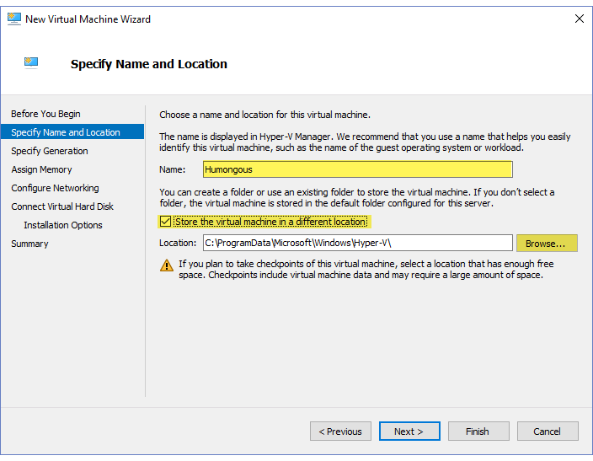

1. In the **Select Folder** dialog box, navigate to **C:\RonsNotes**.
2. Within the **RonsNotes** folder, create a new folder named VM_Drives.
3. Double-click to open **VM_Drives** folder.
4. Within the **VM_Drives** folder, create a new folder named Humongous.
5. Double-click to open **Humongous** folder.
6. Click **Select Folder**, then review your settings.

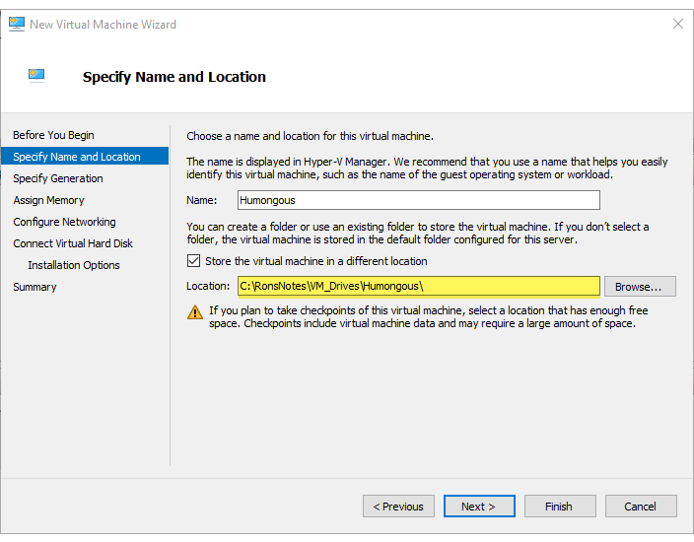

1. Click **Next.**
2. In the **Specify Generation** dialog box, review the settings, then click **Next**.

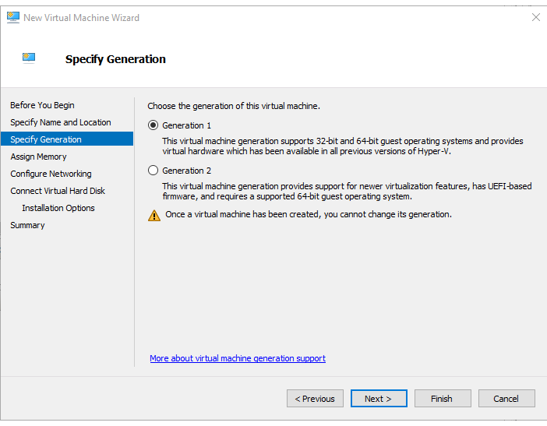

1. In the **Assign Memory** dialog box, set the **Startup memory** to 4000**MB**.
2. Verify there is a check in the **Dynamic Memory** check box.
3. Click **Next**.
4. In the **Configure Networking** dialog box, move to the **Connection** setting, use the corresponding drop-down arrow and click to connect to the **VMExternal** adapter.

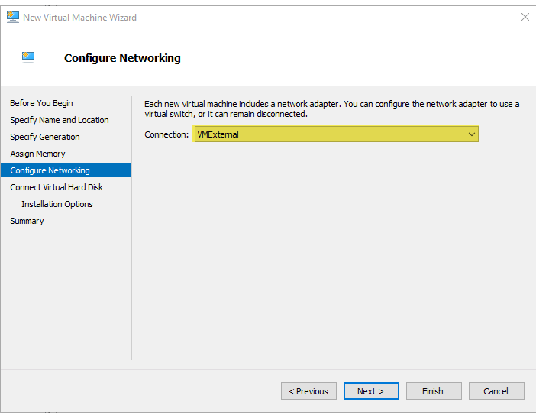

1. Click **Next**.
2. In the **Connect Virtual Hard Disk** dialog box, change the **Size** of the virtual hard disk to 80**GB**.
3. Click **Next.**
4. In the **Installation Options** dialog box, review the settings and leave the radio button to **Install an operating system later** selected.
5. Click **Next**.
6. In the **Completing the New Virtual Machine Wizard** dialog box, review the settings, then click **Finish**.

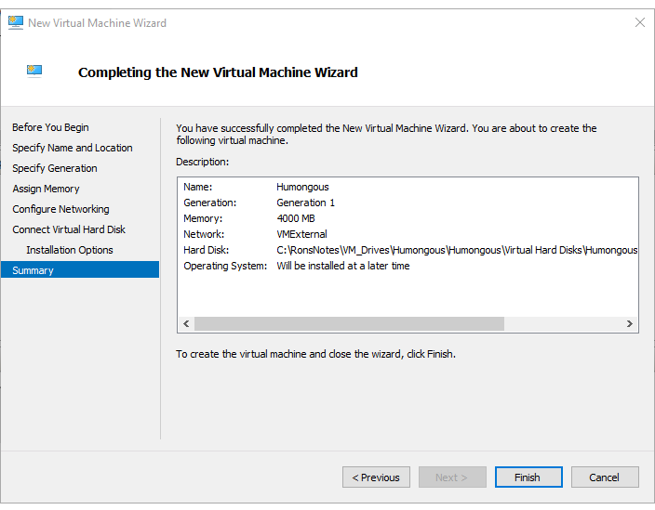

1. In **Hyper-V Manager**, click to select **Humongous** virtual machine, then right-click the machine and select **Settings…**.
2. When **Settings for Humongous …** dialog box opens, review the options available.
3. Navigate to the pane on the left, then locate and click to select **Processor** tab.
4. Verify the **Number of virtual processors** is set to **4**.
5. If changes were made, click **Apply**.

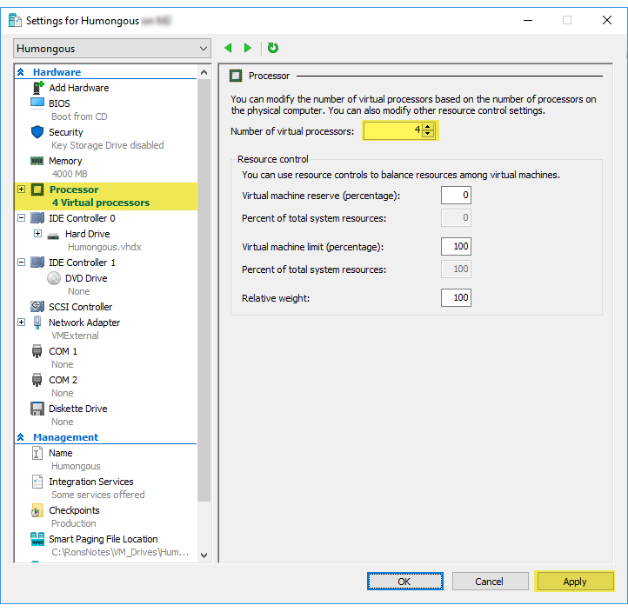

1. Move back to the pane on the left and click to select **IDE Controller 0**.
2. Locate the **Select the type of drive you want to attach to the controller**… setting, click to select **DVD Drive**, then click **Add**.

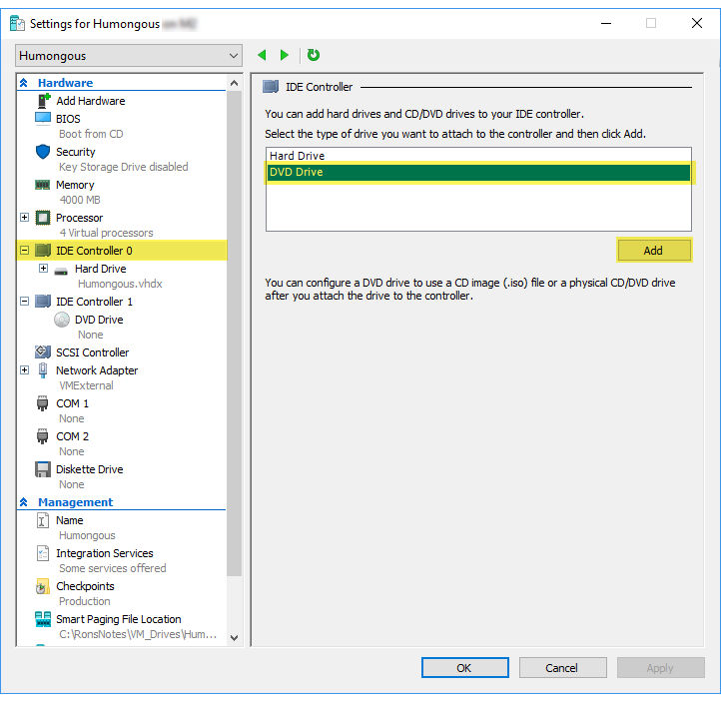

1. Click the radio button to select an **Image file**, then click the corresponding **Browse…**.
2. In the **Open** dialog box, navigate to **C:\RonsNotes\ISOs\Server2016** and double-click the installation ISO.
3. Back in **Settings for Humongous**… dialog box, review the settings.

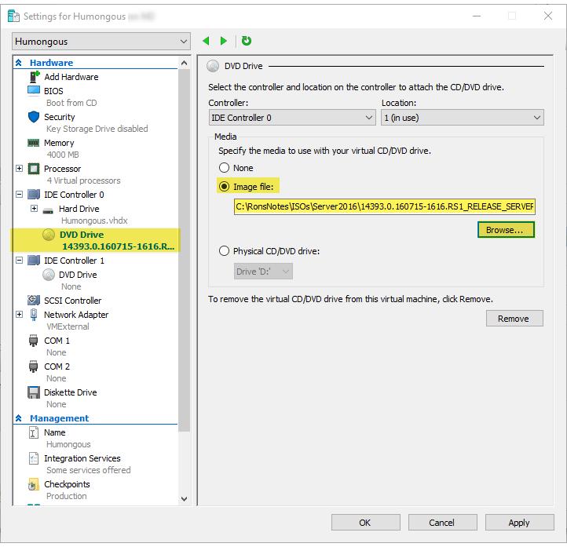

1. Click **Apply**.
2. Move back to the pane on the left and click to select **DVD Drive** below **IDE Controller 1**.
3. Click the radio button to select an **Image file**, then click the corresponding **Browse…**.
4. In the **Open** dialog box, navigate to **C:\RonsNotes\ISOs\SQL2016** and double-click the installation ISO.
5. Back in **Settings for Humongous**… dialog box, review the settings.

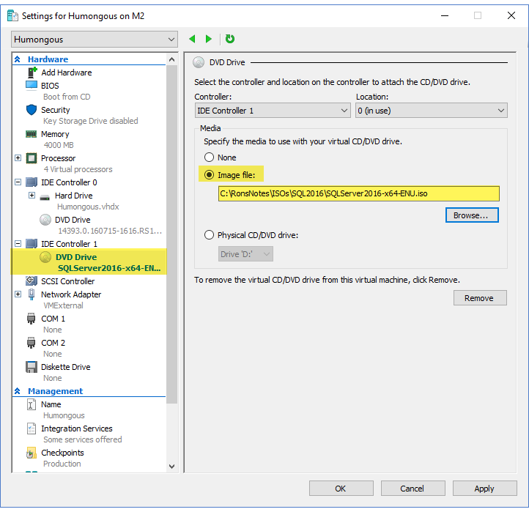

1. Click **Apply**.
2. Click **OK**.

### Installing Windows Server 2016

*Note: there is no equivalent to this task in PowerShell.*

#### Task: Install Server 2016

The next set of instructions is repeated for each virtual machine.

1. Right-click the virtual machine (**Humongous**), then click **Start**.
2. Again, right-click the virtual machine (**Humongous**), then click **Connect**.
3. In the **Windows Setup** dialog box, review the settings, then click **Next**.

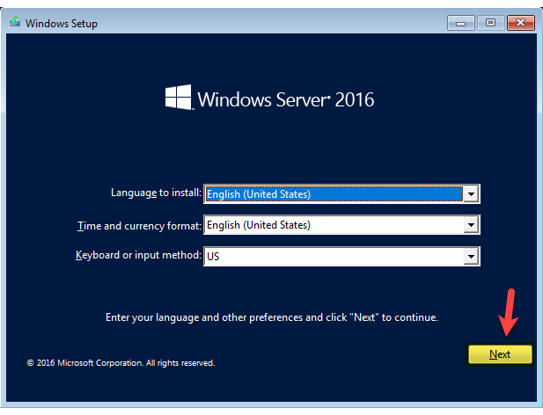

1. Click **Install now**.

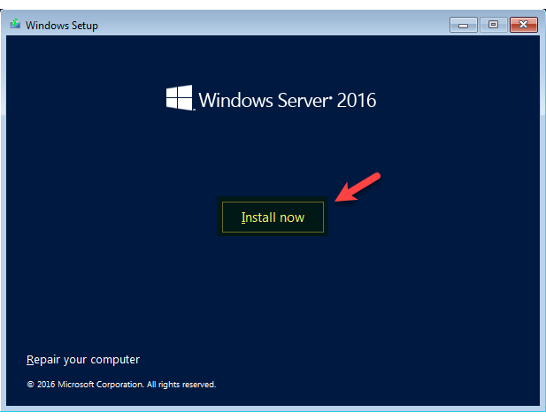

1. In the **Select the operating system you want to install** dialog box, click to select the second option **Windows Server 2016 Standard Evaluation (Desktop Experience)**.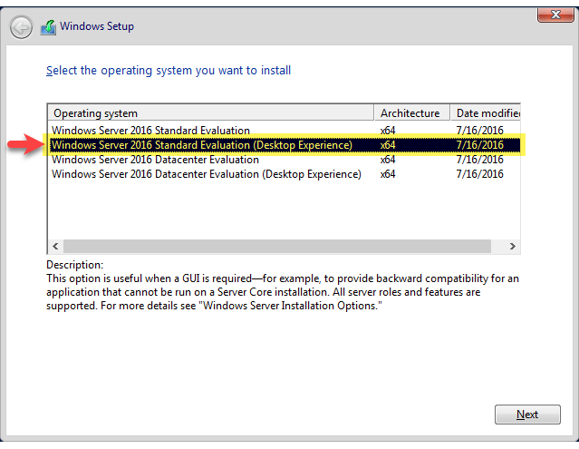
2. Click **Next**.
3. Accept the license, then click **Next**.

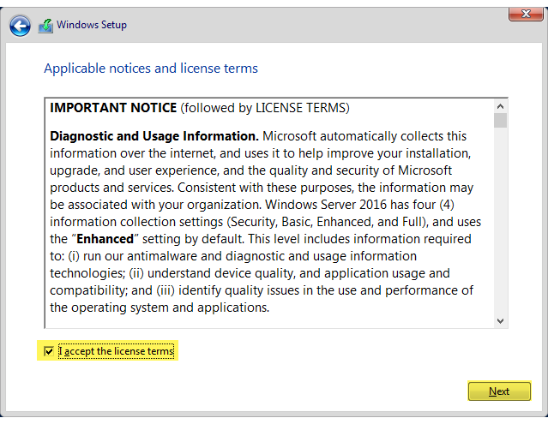

1. In the **Which type of installation do you want** dialog box, click to select **Custom: Install Windows only (advanced)**.

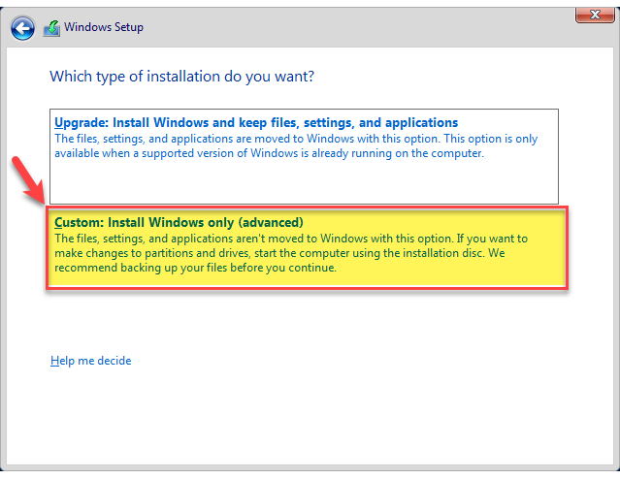

1. When the **Where do you want to install Windows** dialog box opens, review the settings, then click **Next**.

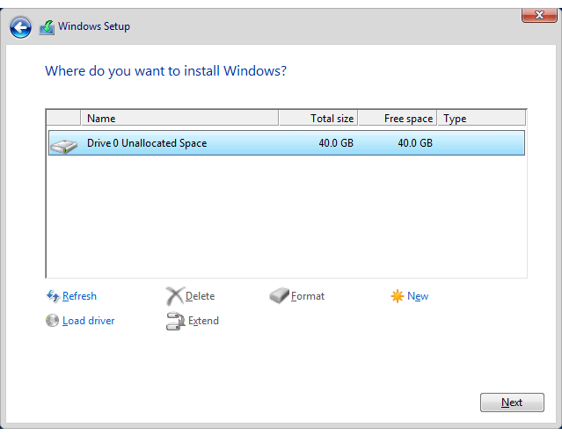

1. Wait for installation to complete.
2. In the **Customize settings** prompt, move to the **Password** text box and enter Passw0rd, then reenter the same in the **Reenter password** text box.

*The 0 is numeric.*

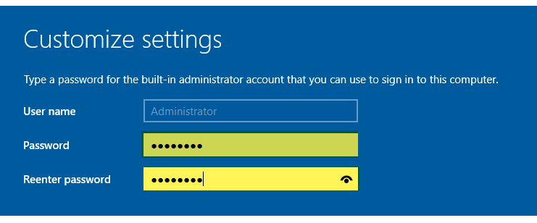

1. Navigate to the lower-right and click **Finish**.
2. Log on to the virtual machine by utilizing the key sequence of **Ctrl+Alt+End**, or by clicking on the **Ctrl+Alt+Delete** icon () in the toolbar.
3. Enter Passw0rd into the **Password** prompt to log in as **Administrator**.

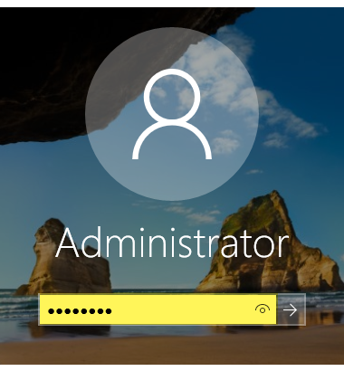

1. Allow the virtual machine to fully start (wait for **Server Manager** to open).
2. You will see a prompt on the right asking **Do you want to allow your PC to be discoverable by other PCs and devices on this network**, click **Yes**.

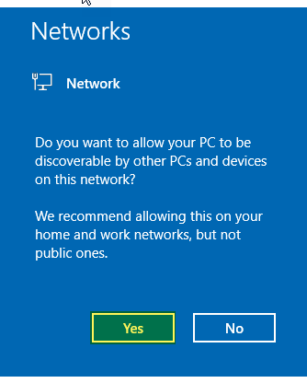

*If the virtual machine remains black, then use Hyper-V Manager to shut it down, then restart it.*

*Optional step:*

* 1. *You can run update on the virtual machine server. This will take a long time as you need to do it on all of them. We have tested this build with Server 2016 as-is, without any updates, and it all worked, but this is strictly your call.*
  2. *To run an update, open Server Manager, click to select Local Server, then click the corresponding hyperlink to search for and install updates.*

*Note. Until we connect these VMs to the internet they will not authenticate meaning you have ten days to get past that phase of the setup.*

1. Once Windows Server 2016 is installed successfully, switch to **Hyper-V Manager**, right-click the virtual machine (**Humongous**), then click **Shut Down…**.
2. In the dialog box asking, **Are you sure you want to shut down the operating system in the selected virtual machines(s)**, click **Shut Down**.

## Phase 03 Domain Setup

### Phase Objective

In this phase, we will copy files to the individual virtual machines, then configure the network adapters and build a domain.

### Phase Topics

* Enabling Integration Services
* Copying Files to the Individual Virtual Machines
* Removing External Network Adapter
* Adding Private Network Adapter
* Renaming the Virtual Machine
* Creating the Domain
* Building out the Domain

### Enabling Guest Services on the Virtual Machine

#### Task: Enabling Guest Services on the Virtual Machine

* If you prefer the PowerShell script instructions for this task, click here.

#TASK: ENABLING GUEST SERVICES ON THE VIRTUAL MACHINE

$VMName = "Humongous"

Enable-VMIntegrationService -VMName $VMname -Name "Guest Service Interface"

1. In **Hyper-V Manager**, click to select **Humongous**, then right-click the virtual machine and select **Settings…**.
2. Move to the pane on the left, then locate and click to select **Integration Services** tab.
3. Verify there is a check in the **Guest services** check box.

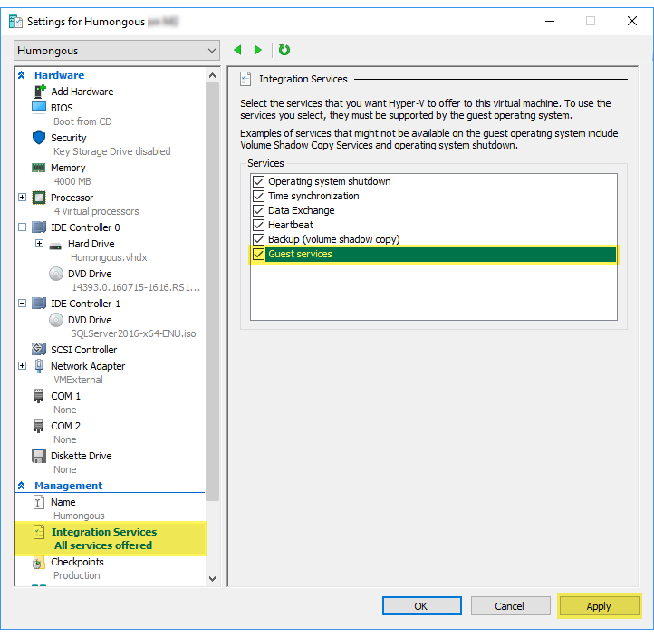

1. If changes were made, click **Apply**.
2. Click **OK**.

### Starting the Virtual Machine

#### Task: Starting the Virtual Machine

* If you prefer the PowerShell script instructions for this task, click here.

#TASK: STARTING THE VIRTUAL MACHINE

$VMName = "Humongous"

$VMName | Start-VM

1. Switch to **Hyper-V Manager** and click to select **Humongous**virtual machine.
2. Press **Ctrl+A** to select all virtual machines.
3. Right-click the selected machines, then click **Start**.

### Copying Files to the Individual Virtual Machine

The PowerShell script version of this section of the course will copy the needed files directly to the virtual machine. Without the use of PowerShell, this process becomes a bit trickier.

#### Task: Copying Files to the Virtual Machine

* If you prefer the PowerShell script instructions for this task, click here.

#TASK: COPYING FILES TO THE VIRTUAL MACHINE

Function CopyFiles-Humongous{

$VMName = "Humongous"

$CSS = Get-ChildItem 'C:\RonsNotes\Script_Folders\HumongousScripts'

$CSS

foreach ($s in $CSS){

Copy-VMFile $VMName -FileSource Host -SourcePath "C:\RonsNotes\Script_Folders\HumongousScripts\$s" -DestinationPath c:\ -CreateFullPath -Force

}

Copy-VMFile Humongous-FileSource Host -SourcePath C:\RonsNotes\ISOs\Sharepoint2016\officeserver.img -DestinationPath c:\ -CreateFullPath -Force

} #End

CopyFiles-Humongous

1. Switch to **Hyper-V Manager**.
2. Right-click **Humongous** virtual machine, then click **Connect**.
3. In **Connect to Humongous** dialog box, review the options available, then click **Connect**.
4. Log on to the virtual machine by utilizing the key sequence of **Ctrl+Alt+End**, or by clicking on the **Ctrl+Alt+Delete** icon () in the toolbar.
5. Enter Passw0rd into the **Password** prompt to log in as **Administrator**.



1. Allow the virtual machine to fully start (wait for **Server Manager** to open).
2. Start **File Explorer**.
3. Navigate to the pane on the left and click to select **Network**.

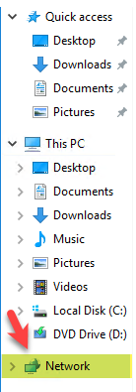

1. Notice a yellow bar has appeared along the top of the dialog box advising that **File sharing is turned off**.

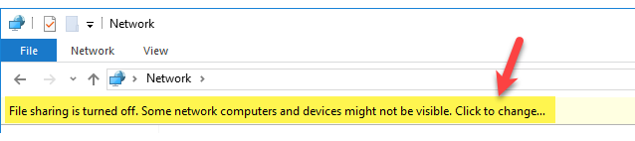

1. Click the yellow bar, then click

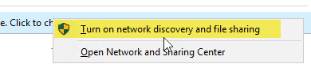

*If you encounter the Network discovery and file sharing dialog box asking Do you want to turn on network discovery and file sharing for all public networks, click No, make the network that I am connected to a private network.*

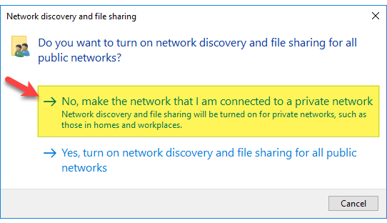

1. Back in **File Explorer**, navigate to the pane on the left and click to select **Network**.
2. Double-click to connect to your host machine.
3. In the **Windows Security** dialog box, enter your **User name** and **Password** to log into the host machine.

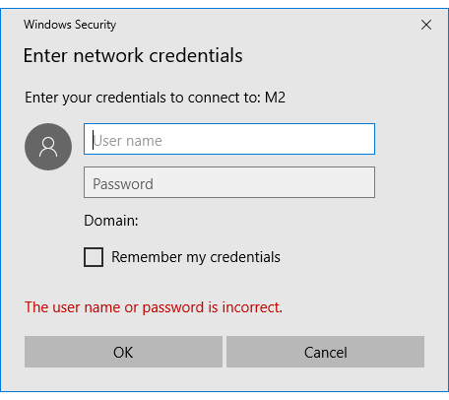

1. Double-click to open the **Users** folder.

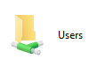

1. Double-click to open the user profile you are working in.
2. Switch to the host machine.
3. Start **File Explorer** and navigate to **C:\RonsNotes\ISOs\Sharepoint2016**.

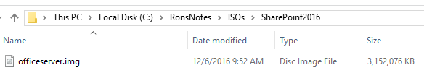

1. Click to select **officeserver.img**, then right-click the same file and click **Cut**.
2. Navigate to the pane on the left and click to select **Local Disk (C:)**.
3. Double-click to open **Users** folder.
4. Double-click to open the user folder for the profile you are currently utilizing.

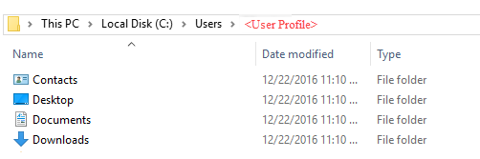

1. Press **Ctrl+V** to paste in the image you copied.
2. Switch to your virtual machine.
3. Back in **File Explorer**, notice you now see the **officeserver.img** file.
4. Click to select **officeserver.img**, then right-click the same file and click **Copy**.
5. Navigate to the pane on the left and click to select **Local Disk (C:)**.
6. Create a new folder and name the folder SharePoint2016.
7. Double-click to open **SharePoint2016** folder.
8. Press **Ctrl+V** to paste in the image you copied.
9. Minimize this virtual machine.
10. Utilizing **Hyper-V Manager**, shut down the virtual machine.

### Adding Private Network Adapter

#### Task: Adding Private Network Adapter

1. In **Hyper-V Manager**, click to select **Humongous**, then right-click the virtual machine and select **Settings…**.
2. Move to the pane on the left, then locate and click to select **Add Hardware**.
3. Move to the setting in the center and click to select **Network Adapter**, then click **Add**.

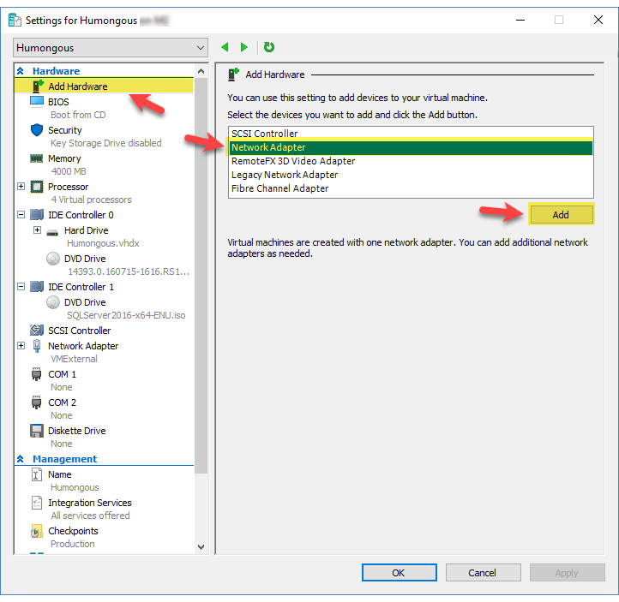

1. Move to the **Virtual switch** setting, use the corresponding drop-down arrow and click to select the **VMPrivate** connection.
2. Click **Apply**.

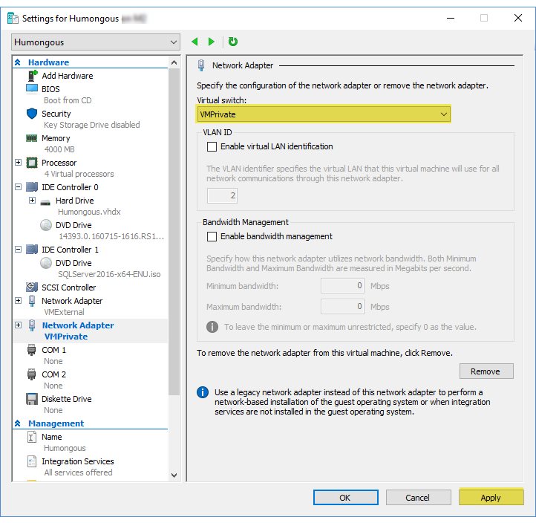

1. Click **OK**.

### Renaming the Virtual Machine

#### Task: Renaming the Virtual Machine

* If you prefer the PowerShell script instructions for this task, click here.

#TASK: RENAMING THE VIRTUAL MACHINE

Rename-Computer -NewName Humongous -Restart -Force

1. Switch to **Hyper-V Manager**.
2. Right-click **Humongous** virtual machine, then click **Start**.
3. Again, right-click **Humongous** virtual machine, then click **Connect**.
4. In **Connect to Humongous** dialog box, review the options available, then click **Connect**.

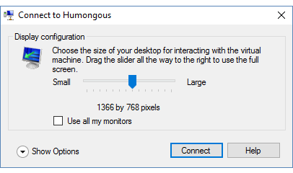

1. Log on to the virtual machine by utilizing the key sequence of **Ctrl+Alt+End**, or by clicking on the **Ctrl+Alt+Delete** icon () in the toolbar.
2. Enter Passw0rd into the **Password** prompt to log in as **Administrator**.



1. Allow the virtual machine to fully start (wait for **Server Manager** to open).
2. When **Server Manager** opens, navigate to the pane on the left and click **Local Server**.

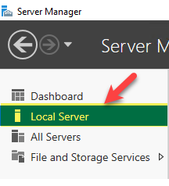

1. Locate the **Computer name** setting, note the current name, then click the corresponding link.

*Note: your computer name will not directly match the one shown below.*

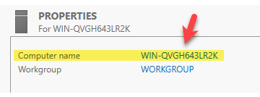

1. In the **System Properties** dialog box, click **Change…**.

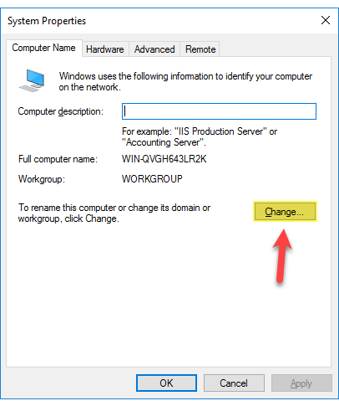

1. When the **Computer Name/Domain Changes** dialog box opens, move to the **Computer name** text box and enter Humongous.

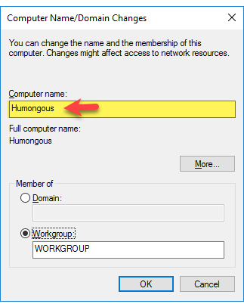

1. Click **OK**.
2. In the dialog box advising **You must restart your computer to apply these changes**, click **OK**.
3. Click **Close**.
4. In the dialog box advising **You must restart your computer to apply these changes**, click **Restart Now**.
5. Wait for the machine to reboot.
6. Log on to the virtual machine by utilizing the key sequence of **Ctrl+Alt+End**, or by clicking on the **Ctrl+Alt+Delete** icon () in the toolbar.
7. Enter Passw0rd into the **Password** prompt to log in as **Administrator**. *(The 0 is numeric.)*
8. Allow the virtual machine to fully start (wait for **Server Manager** to open).
9. When **Server Manager** opens, navigate to the pane on the left and click **Local Server**.
10. Locate the **Computer name** setting and note the current name.

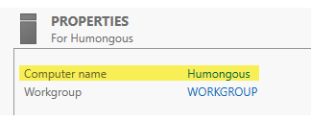

### Creating the Domain and Configuring the Forest

#### Task: Creating the Domain

* If you prefer the PowerShell script instructions for this task, click here.

#TASK: CREATING THE DOMAIN

Install-windowsfeature -name AD-Domain-Services -IncludeManagementTools

$domain_Name = "RonsNotes.training.local"

$secure_string_pwd = ConvertTo-SecureString "Passw0rd" -asplaintext -Force

1. Switch back to **Humongous** virtual machine.
2. In **Server Manager**, navigate up to the menu in the upper-right and click **Manage** | **Add Roles and Features**.

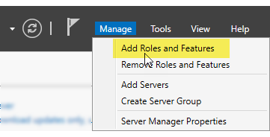

1. In the **Add Roles and Features Wizard** dialog box, review the information given, then click **Next**.

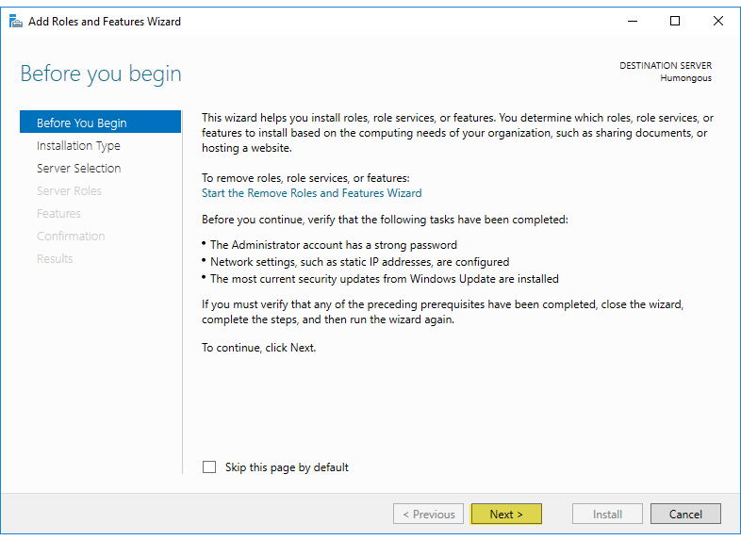

1. In the **Select installation type** dialog box, review the options available, then leave **Role-based or feature-based installation** selected and click **Next**.
2. When the **Select destination server** dialog box opens, review the options available, then leave the settings as they are (**Humongous** selected) and click **Next**.

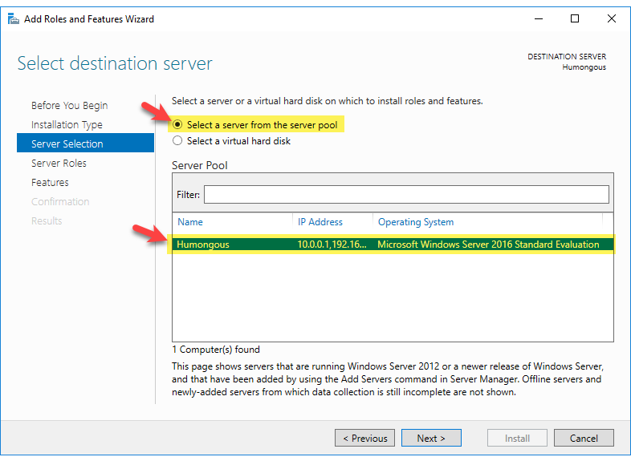

1. In the **Select server roles** dialog box, review the options available, then move to the **Roles** section and place a check in the **Active Directory Domain Services** check box.

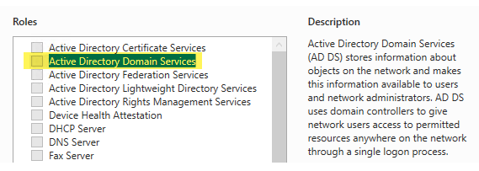

1. When the **Add features that are required for Active Directory Domain Services** dialog box appears, verify there is a check in the **Include management tools (if applicable)** check box.

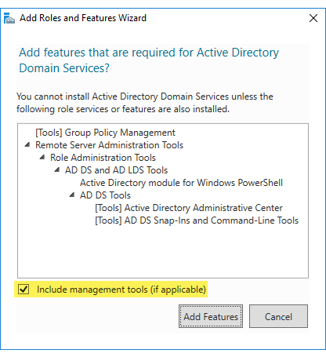

1. Click **Add Features**.
2. Move back to the **Roles** section and place a check in the **DNS Server** check box.

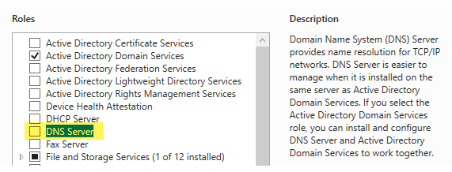

1. When the **Add features that are required for DNS Server** dialog box appears, verify there is a check in the **Include management tools (if applicable)** check box.

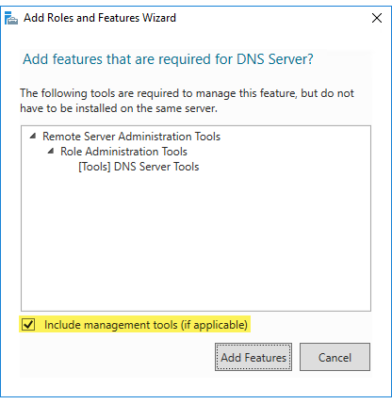

1. Click **Add Features**.
2. Click **Next**.
3. In the **Select features** dialog box, review the options available, then click **Next**.
4. When the **Active Directory Domain Services** dialog box appears, review the information given, then click **Next**.

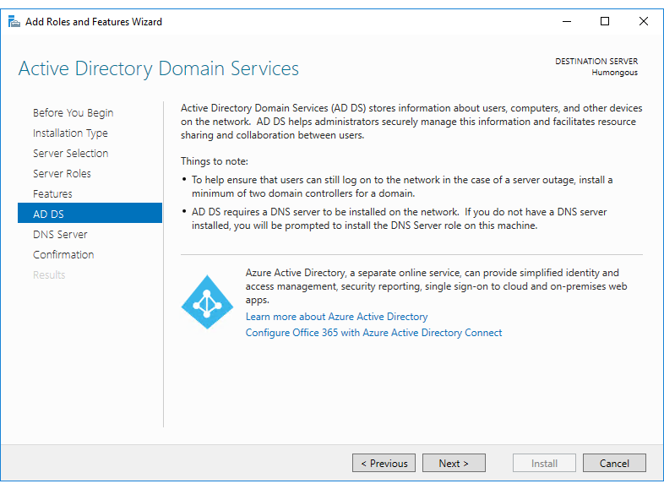

1. In the **DNS Server** dialog box, review the information given, then click **Next**.
2. In the **Confirm installation selections** dialog box, review the settings.
3. Place a check in the **Restart the destination server automatically if required** check box.
4. In the **Add Roles and Features Wizard** dialog box asking **Do you want to allow automatic restarts**, click **Yes**.
5. Back in **Confirm installation selections** dialog box, click **Install**.

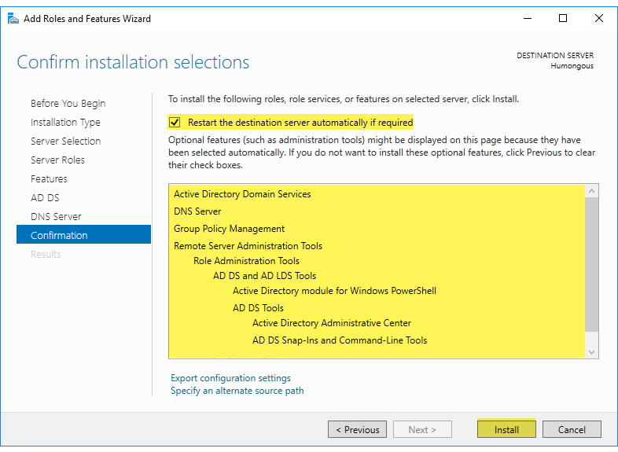

1. Upon success, you will see a message advising that **Installation succeeded on Humongous**, then click **Close**.

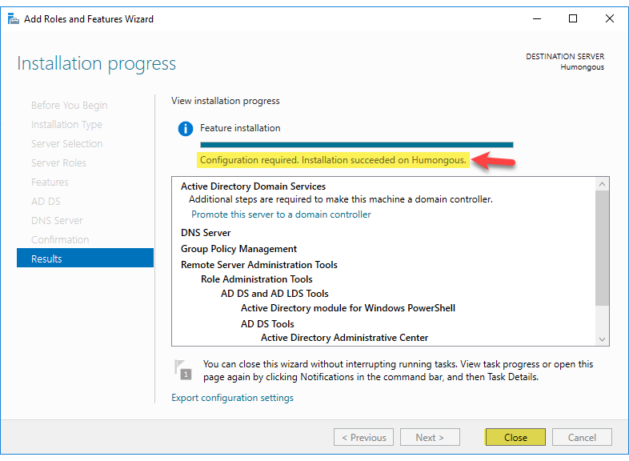

1. If the virtual machine does not reboot, manually reboot the machine.

#### Task: Configuring the Forest

* If you prefer the PowerShell script instructions for this task, click here.

#TASK: CONFIGURING THE FOREST

Install-ADDSForest -DomainName $domain_Name -SkipPreChecks -InstallDns:$true -DomainNetbiosName RonsNotes -SafeModeAdministratorPassword $secure_string_pwd -Force

1. Once the machine comes back up from the reboot, back in **Server Manager**, notice a yellow warning in the upper-right.

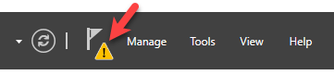

1. Click the flag, then review the information given and click the **Promote this server to a domain controller** link.

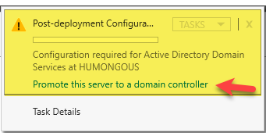

1. In the **Deployment Configuration** dialog box, review the options available, then click the radio button to **Add a new forest**.
2. Move to the **Root domain name** text box and enter RonsNotes.training.local.

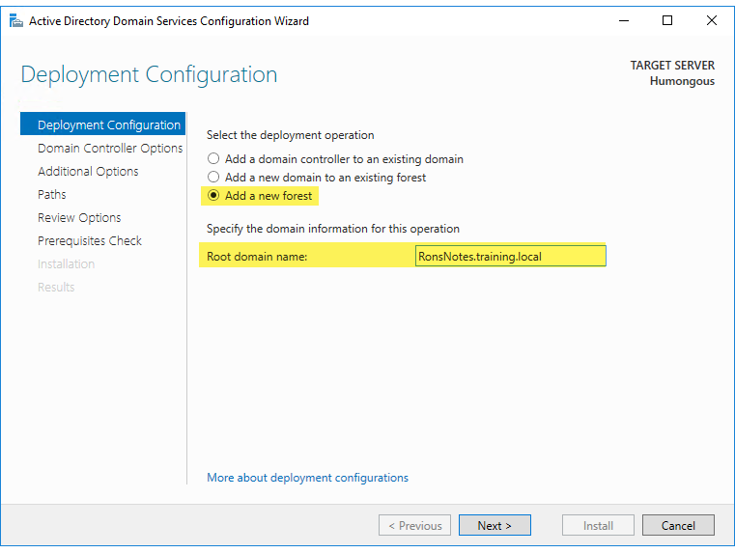

1. Click **Next**.
2. In the **Domain Controller Options** dialog box, review the current settings.
3. Move to the **Password** text box and enter Passw0rd. *(The 0 is numeric.)*
4. Confirm Passw0rd in the **Confirm password** text box. *(The 0 is numeric.)*

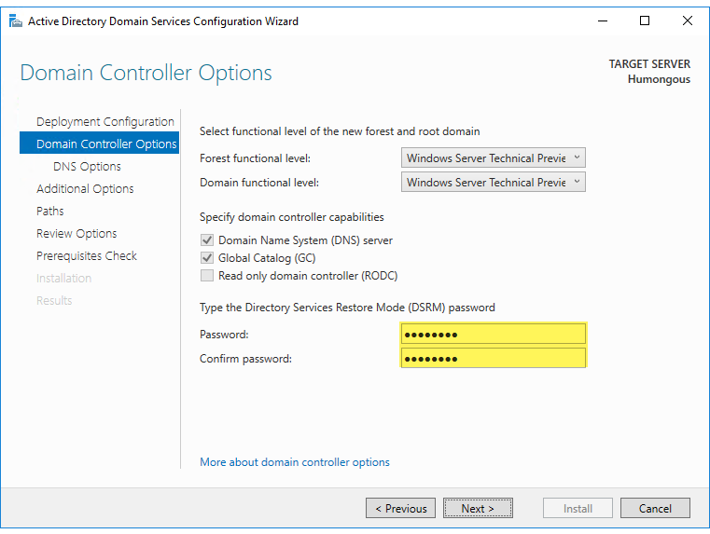

1. Click **Next**.
2. In the **DNS Options** dialog box, review the information given, then click **Next**.

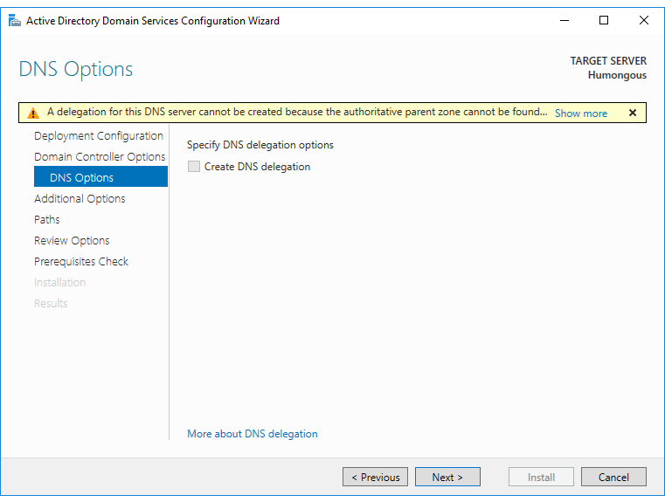

1. In the **Additional Options** dialog box, review the settings, then click **Next**.

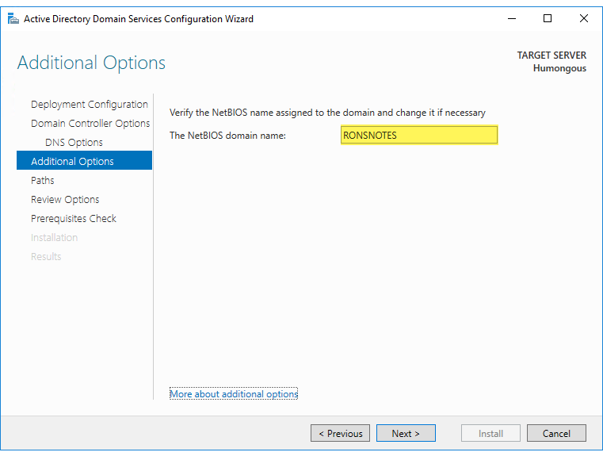

1. In the **Paths** dialog box, review the settings, then click **Next**.
2. In the **Review Options** dialog box, review the settings then click **Next**.
3. In the **Prerequisites Check** dialog box, wait for the message to indicate that **All prerequisite checks passed successfully**, then click **Install**.

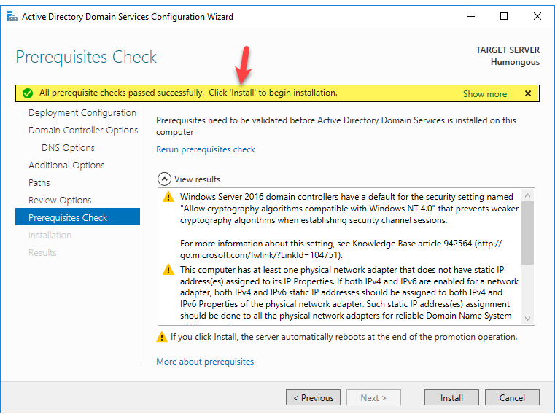

1. When the **Installation** dialog box appears, wait for installation to complete. Upon success, the virtual machine will restart.
2. When **Humongous** virtual machine starts back up, log on to the virtual machine by utilizing the key sequence of **Ctrl+Alt+End**, or by clicking on the **Ctrl+Alt+Delete** icon () in the toolbar.
3. Enter Passw0rd into the **Password** prompt to log in as **Administrator**.

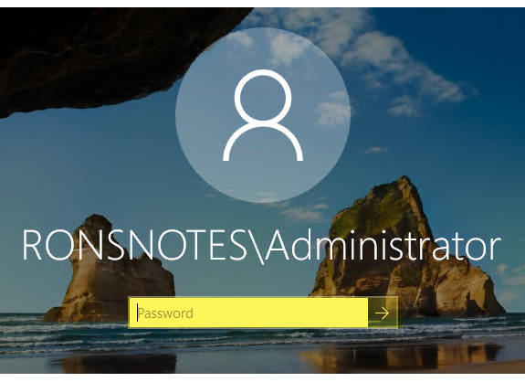

1. Allow the virtual machine to fully start (wait for **Server Manager** to open).
2. When **Server Manager** opens, navigate to the pane on the left and click **Local Server**.
3. Locate the **Domain** setting and note the current domain.

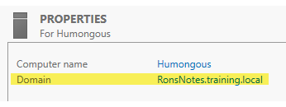

#### Task: Configure Network Adapter on Humongous

*There is no PowerShell script equivalent provided with this course.*

1. Switch back to **Humongous** virtual machine.
2. Navigate to the lower-right, right-click , then click **Open Network and Sharing Center**.
3. Move to the **Connections** setting and click the **Ethernet 2** link.

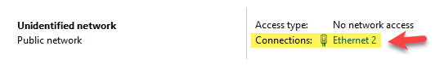

1. When **Ethernet 2 Status** dialog box opens, click **Properties**.

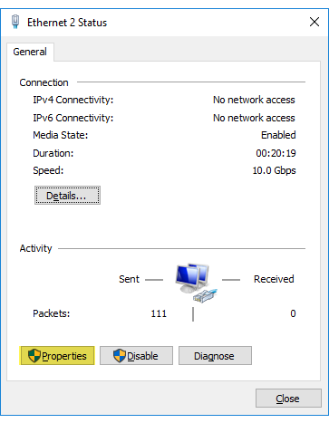

1. When **Ethernet 2 Properties** dialog box opens, review the settings and options available.

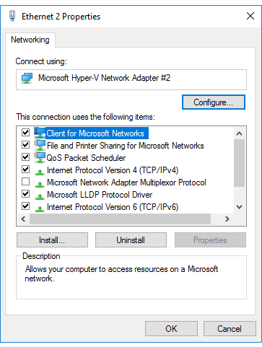

1. Move to the **This connection uses the following items** section and click to select **Internet Protocol Version 4 (TCP/IPv4)**.
2. Click **Properties**.

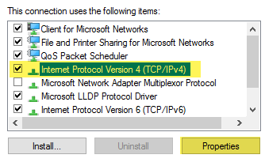

1. In the **Internet Protocol Version 4 (TCP/IPv4) Properties** dialog box, review the options and settings available.

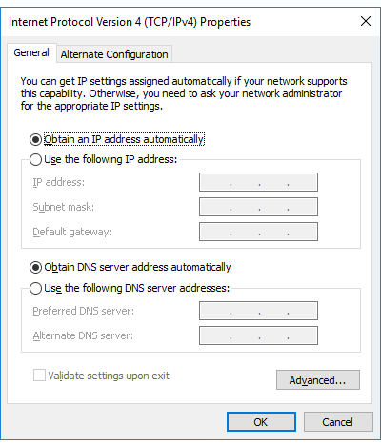

1. Click the radio button to **Use the following IP address**.
2. Move to the **IP address** setting and enter 10.0.0.1.
3. Click into the **Subnet** **mask** setting and notice the values were automatically entered.
4. Click the radio button to **Use the following DNS server addresses**.
5. Move to the **Preferred DNS** **server** setting and enter 10.0.0.1.

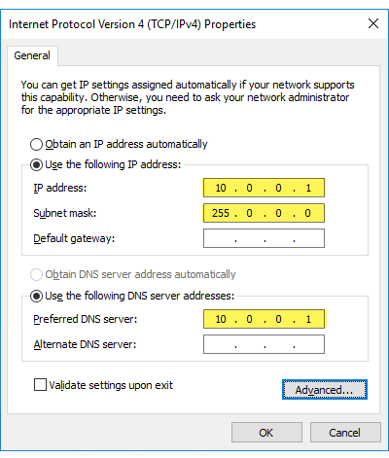

1. Click **OK**.
2. Back in **Ethernet 2 Properties** dialog box, click **Close**.
3. Back in the **Ethernet 2 Status** dialog box, click **Close**.
4. Close **Network and Sharing Center**.
5. Press **Windows** key and enter Power.
6. Right-click **Windows PowerShell ISE** icon, then click **Run as administrator**.
7. In the **User Account Control** dialog box, click **Yes**.
8. When **Windows PowerShell ISE** opens, review the options and settings available.
9. Move to the text editor portion of the interface and enter Ping 10.0.0.1.

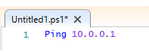

1. Move to the toolbar above and click  to **Run Script**.
2. Review the results.

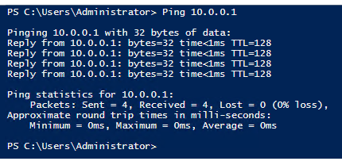

1. Move to the text editor portion of the interface, place your cursor at the end of line **1** and press **Enter** to move to the next line below.
2. Enter IPconfig.

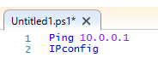

1. With your cursor at the end of line **2**, move to the toolbar above and click  to **Run Selection**.
2. Review the results.

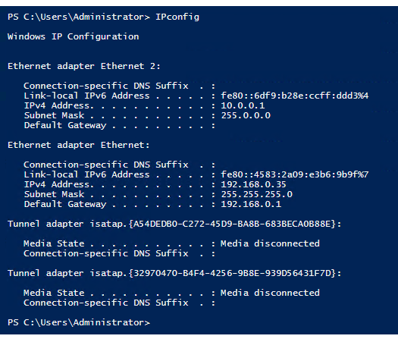

1. Close **PowerShell ISE**, and when prompted to save changes, click **No**.

#### Task: Create Student as Domain Administrator

* If you prefer the PowerShell script instructions for this task, click here.

#TASK: CREATE STUDENT AS DOMAIN ADMINISTRATOR

New-ADUser -SamAccountName 'Student' -AccountPassword (ConvertTo-SecureString Passw0rd -AsPlainText -Force) -UserPrincipalName 'Student' -DisplayName 'Student' -Name 'Student' -Enabled $true

Add-ADGroupMember -Identity 'Enterprise admins' Student

Add-ADGroupMember -Identity 'Domain Admins' Student

1. In **Humongous**, navigate up to the menu in the upper-right and click **Tools | Active Directory Users and Computers**.

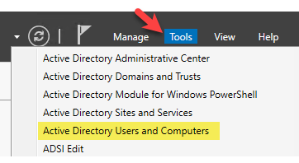

1. When **Active Directory Users and Computers** opens, review the options available.

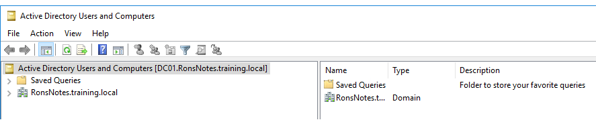

1. Move to the pane on the left and expand **RonsNotes.training.local**.

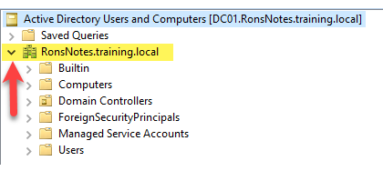

1. Click to select the **Users** folder.
2. Move to the section in the center, right-click **Administrator** and click **Copy…**.

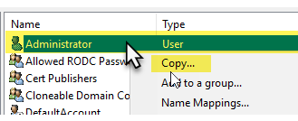

1. In the **Copy Object – User** dialog box, move to the **First name** text box and enter Student.
2. Navigate to the **User logon name** text box and enter Student.

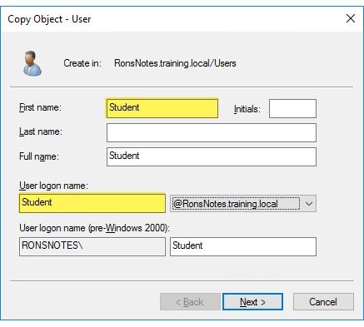

1. Click **Next**.
2. Move to the **Password** text box and enter Passw0rd. *(The 0 is numeric.)*
3. Move to the **Confirm password** text box and enter Passw0rd. *(The 0 is numeric.)*
4. Verify there is a check in the **Password never expires** check box.

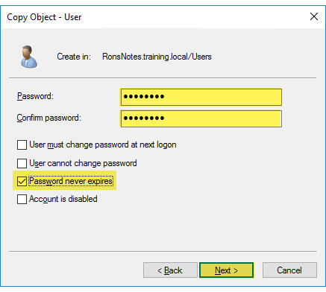

1. Click **Next**.
2. Click **Finish** and notice that **Student** is now listed at the bottom of the list.
3. Close **Active Directory Users and Computers**.
4. Press **Ctrl+Alt+End**.
5. Click **Sign out**.
6. Press **Ctrl+Alt+End**.
7. Navigate to the lower-left and click **Other user**.
8. Move to the **User name** text box and enter Student.
9. In the **Password** text box enter Passw0rd.

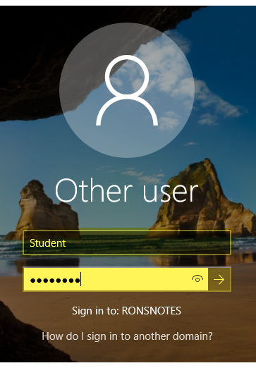

1. Allow the virtual machine to fully start (wait for **Server Manager** to open).

#### Task: Turn Off the Firewall

* If you prefer the PowerShell script instructions for this task, click here.

#TASK: TURN OFF THE FIREWALL

Set-NetFirewallProfile -Profile domain,Public,Private -Enabled False

1. Connect to the virtual machine and log in as **Student**.
2. When **Server Manager** opens, move to the pane on the left and click **Local Server** tab.
3. Move to the **Properties** section in the center, locate the **Windows Firewall** setting and click the **Public: On** link.

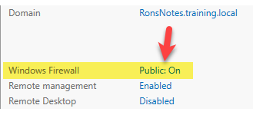

1. Navigate to the pane on the left and click **Turn Windows Firewall on or off**.

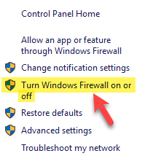

1. When **Customize settings for each type of network** opens, review the current settings.

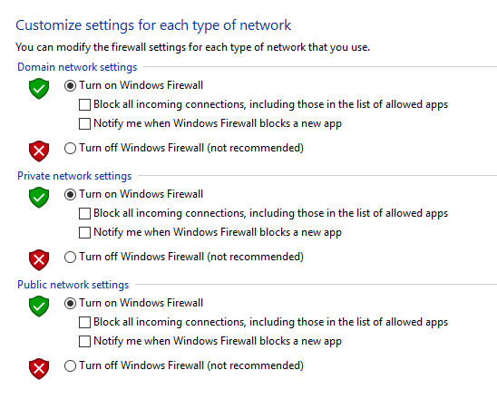

1. Click the radio button to **Turn off Windows Firewall** for all three network settings:
   * Domain
   * Private
   * Public

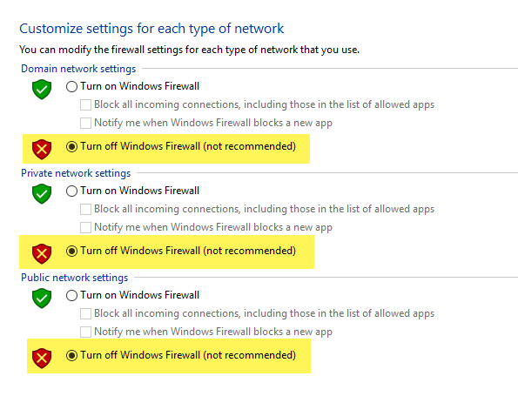

1. Click **OK**.
2. Close **Control Panel**.

#### Task: Create Organizational Units

* If you prefer the PowerShell script instructions for this task, click here.

#TASK: CREATE ORGANIZATIONAL UNITS

Function Create-OUs{

New-ADOrganizationalUnit -Name Sharepoint_Svrs -Path "DC=RonsNotes, DC=Training, DC=Local"

New-ADOrganizationalUnit -Name SQL_Svrs -Path "DC=RonsNotes, DC=Training, DC=Local"

New-ADOrganizationalUnit -Name RN_Users -Path "DC=RonsNotes, DC=Training, DC=Local"

New-ADOrganizationalUnit -Name SP_Owners -Path "OU=RN_Users, DC=RonsNotes, DC=Training, DC=Local"

New-ADOrganizationalUnit -Name SP_Members -Path "OU=RN_Users, DC=RonsNotes, DC=Training, DC=Local"

New-ADOrganizationalUnit -Name SP_Visitors -Path "OU=RN_Users, DC=RonsNotes, DC=Training, DC=Local"

New-ADOrganizationalUnit -Name SP_Designers -Path "OU=RN_Users, DC=RonsNotes, DC=Training, DC=Local"

New-ADOrganizationalUnit -Name SP_Approvers -Path "OU=RN_Users, DC=RonsNotes, DC=Training, DC=Local"

New-ADOrganizationalUnit -Name Svc_Accounts -Path "OU=RN_Users, DC=RonsNotes, DC=Training, DC=Local"

New-ADOrganizationalUnit -Name SQLDba -Path "DC=RonsNotes, DC=Training, DC=Local"

}

Create-OUs

1. Navigate up to the menu in the upper-right and click **Tools | Active Directory Users and Computers**.
2. When **Active Directory Users and Computers** opens, review the options available.
3. Move to the pane on the left and expand **RonsNotes.training.local**.
4. Right-click **RonsNotes.training.local**, then click **New | Organizational Unit**.

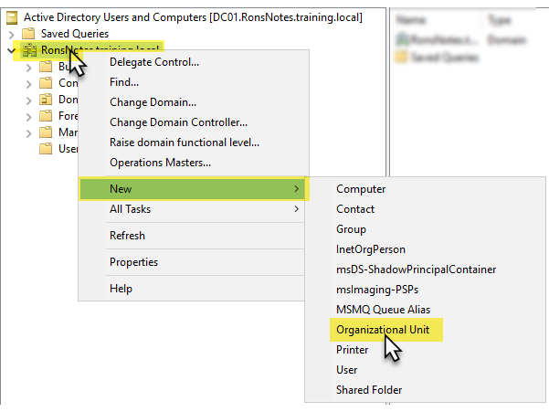

1. In the **New Object – Organizational Unit** dialog box, move to the **Name** text box and enter RN_Users.

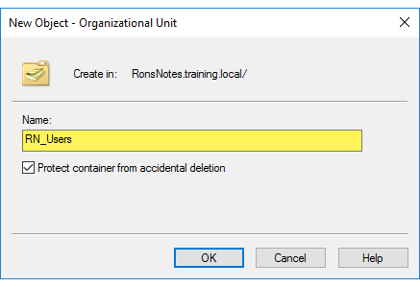

1. Review the remaining settings, then click **OK**.
2. Notice back in the pane on the left you now see **RN_Users** listed.

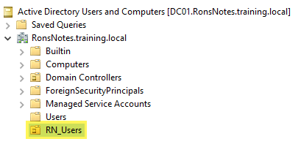

1. Repeat the last three steps to create the following additional Organizational Units:
   * Sharepoint_Svrs
   * SQL_Svrs
   * SQLDba

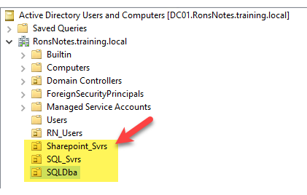

1. Click to select **RN_Users**, then right-click **RN_Users**, and click **New | Organizational Unit**.

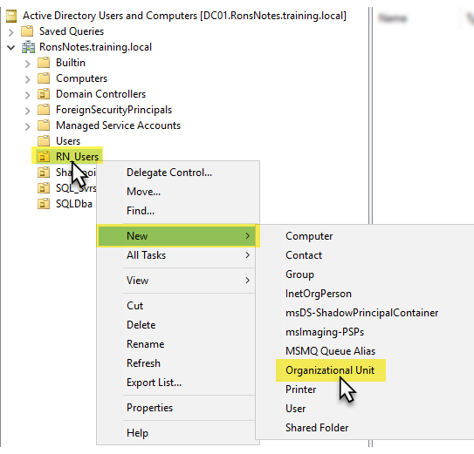

1. In the **New Object – Organizational Unit** dialog box, move to the **Name** text box and enter SP_Approvers.

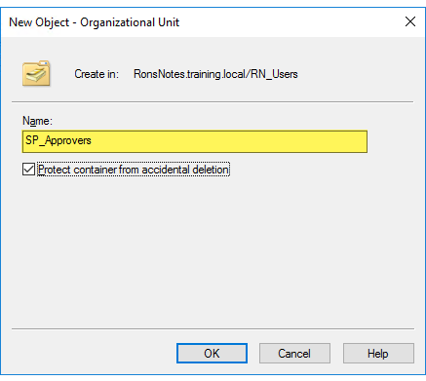

1. Review the remaining settings, then click **OK**.
2. Notice back in the pane on the left you now see **SP_Approvers** listed under **RN_Users**.

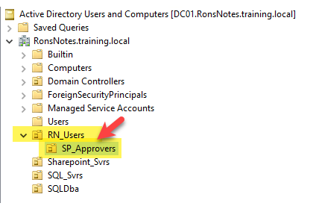

1. Repeat the last three steps to create the following additional Organizational Units within the existing **RN_Users** organizational unit:
   * SP_Designers
   * SP_Members
   * SP_Owners
   * SP_Visitors
   * Svc_Accounts

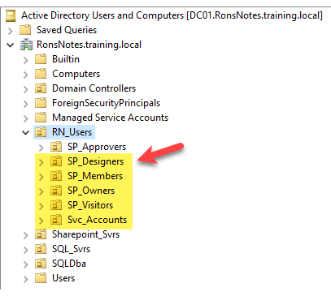

#### Task: Adding Active Directory Users

* If you prefer the PowerShell script instructions for this task, click here.

#TASK: ADDING ACTIVE DIRECTORY USERS

Function Create-AdUserAccounts {

$Password = (ConvertTo-SecureString -AsPlainText "Passw0rd" -Force )

$SvcAccountOU = "OU=SVC_Accounts,OU=RN_Users,DC=RonsNotes, DC=Training, DC=Local"

New-ADUser -Name SVC_Farm -SamAccountName SVC_Farm -AccountPassword $Password -ChangePasswordAtLogon $false -Path $SvcAccountOU -Enabled $true

New-ADUser -Name SVC_WebSvcAccount -SamAccountName SVC_WebSvcAccount -AccountPassword $Password -ChangePasswordAtLogon $false -Path $SvcAccountOU -Enabled $true

New-ADUser -Name SVC_App -SamAccountName SVC_App -AccountPassword $Password -ChangePasswordAtLogon $false -Path $SvcAccountOU -Enabled $true

New-ADUser -Name SVC_Profile -SamAccountName SVC_Profile -AccountPassword $Password -ChangePasswordAtLogon $false -Path $SvcAccountOU -Enabled $true

New-ADUser -Name SVC_Search -SamAccountName SVC_Search -AccountPassword $Password -ChangePasswordAtLogon $false -Path $SvcAccountOU -Enabled $true

New-ADUser -Name SVC_Installation -SamAccountName SVC_Installation -AccountPassword $Password -ChangePasswordAtLogon $false -Path $SvcAccountOU -Enabled $true

New-ADUser -Name SVC_Sync -SamAccountName SVC_Sync -AccountPassword $Password -ChangePasswordAtLogon $false -Path $SvcAccountOU -Enabled $true

New-ADUser -Name SVC_Content -SamAccountName SVC_Content -AccountPassword $Password -ChangePasswordAtLogon $false -Path $SvcAccountOU -Enabled $true

New-ADUser -Name SVC_superReader -SamAccountName SVC_superReader -AccountPassword $Password -ChangePasswordAtLogon $false -Path $SvcAccountOU -Enabled $true

New-ADUser -Name SVC_Unattend -SamAccountName SVC_Unattend -AccountPassword $Password -ChangePasswordAtLogon $false -Path $SvcAccountOU -Enabled $true

New-ADUser -Name SVC_DBA -SamAccountName SVC_DBA -AccountPassword $Password -ChangePasswordAtLogon $false -Path $SvcAccountOU -Enabled $true

New-ADUser -Name Designer_Bobbie -SamAccountName Designer_Bobbie -AccountPassword $Password -ChangePasswordAtLogon $false -Path "OU=SP_Designers,OU=RN_Users,DC=RonsNotes, DC=Training, DC=Local" -Enabled $true

New-ADUser -Name Approver_Kate -SamAccountName Approver_Kate -AccountPassword $Password -ChangePasswordAtLogon $false -Path "OU=SP_Approvers,OU=RN_Users,DC=RonsNotes, DC=Training, DC=Local" -Enabled $true

New-ADUser -Name Member_Sam -SamAccountName Member_Sam -AccountPassword $Password -ChangePasswordAtLogon $false -Path "OU=SP_Members,OU=RN_Users,DC=RonsNotes, DC=Training, DC=Local" -Enabled $true

New-ADUser -Name Owner_Ron -SamAccountName Owner_Ron -AccountPassword $Password -ChangePasswordAtLogon $false -Path "OU=SP_Owners,OU=RN_Users,DC=RonsNotes, DC=Training, DC=Local" -Enabled $true

New-ADUser -Name Visitor_Carlos -SamAccountName Visitor_Carlos -AccountPassword $Password -ChangePasswordAtLogon $false -Path "OU=SP_Visitors,OU=RN_Users,DC=RonsNotes, DC=Training, DC=Local" -Enabled $true

New-ADUser -Name SQLDba -SamAccountName SQLDba -AccountPassword $Password -ChangePasswordAtLogon $false -Path "OU=SQLDba,DC=RonsNotes, DC=Training, DC=Local" -Enabled $true

}

Create-AdUserAccounts

1. Click to select **SP_Approvers**, then right-click **SP_Approvers**, and click **New | User**.

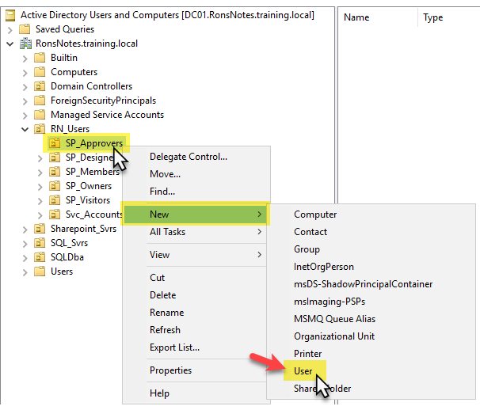

1. In the **New Object – User** dialog box, move to the **First name** text box and enter Approver_Kate.
2. Navigate to the **User logon name** text box and enter Approver_Kate.

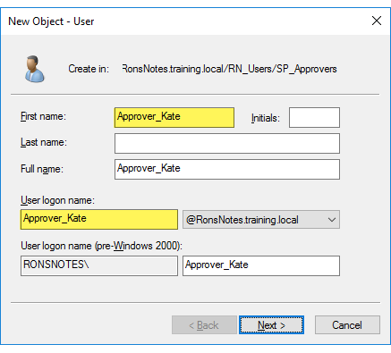

1. Click **Next**.
2. Move to the **Password** text box and enter Passw0rd. *(The 0 is numeric.)*
3. Move to the **Confirm password** text box and enter Passw0rd. *(The 0 is numeric.)*
4. Clear the check from the **User must change password at next logon**.
5. Verify there is a check in the **Password never expires** check box.

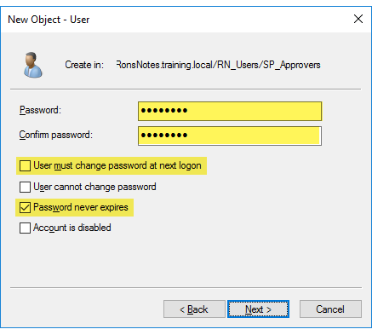

1. Click **Next**.
2. Click **Finish** and notice that **Approver_Kate** is now listed in the center section.

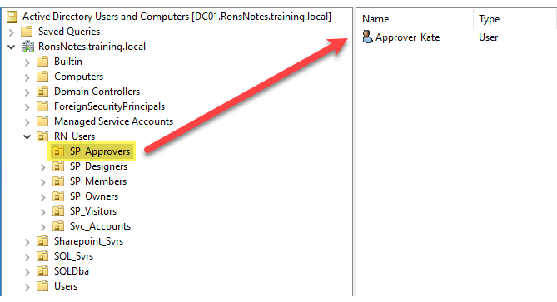

1. Repeat the prior ten steps to create the following users in the corresponding places.

|  |  |
| --- | --- |
| ***Location*** | ***Name*** |
| *RN_Users | SP_Approvers* | *Approver_Kate (COMPLETED ABOVE)* |
| RN_Users | SP_Designers | Designer_Bobbie |
| RN_Users | SP_Members | Member_Sam |
| RN_Users | SP_Owners | Owner_Ron |
| RN_Users | SP_Visitors | Visitor_Carlos |
| RN_Users | Svc_Accounts | SVC_Farm |
| RN_Users | Svc_Accounts | SVC_WebSvcAccount |
| RN_Users | Svc_Accounts | SVC_App |
| RN_Users | Svc_Accounts | SVC_Profile |
| RN_Users | Svc_Accounts | SVC_Search |
| RN_Users | Svc_Accounts | SVC_Installation |
| RN_Users | Svc_Accounts | SVC_Sync |
| RN_Users | Svc_Accounts | SVC_Content |
| RN_Users | Svc_Accounts | SVC_superReader |
| RN_Users | Svc_Accounts | SVC_Unattend |
| RN_Users | Svc_Accounts | SVC_DBA |
| SQLDba | SQLDba |

1. Close **Active Directory Users and Computers**.
2. Minimize **Humongous**.

## Phase 04 Setup SQL Server

### Phase Objective

In this phase, we will set up SQL Server on the virtual machine. Phase Topics

* Install SQL Server 2016
* Install SQL Server Management Studio

#### Task Install SQL Server 2016

*There is no PowerShell script equivalent to this task, however, if you’d rather install SQL Server using an .ini file,* click here *to switch to the PowerShell version of this task.*

1. In **Hyper-V Manager**, click to select **Humongous**, then right-click the virtual machine and select **Start**.
2. Double-click the **Humongous** virtual machine, then click **Connect**.
3. At the logon screen, click **Other user** in the lower-left corner, then log in as **Student**.
4. Start **File Explorer**.
5. Navigate to the pane on the left and click to select **This PC**.

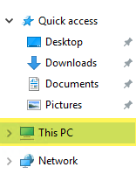

1. Double-click **E:\** drive.

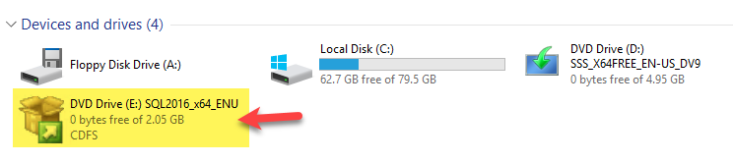

1. When the list of files appears, locate and double-click **Setup**.exe.

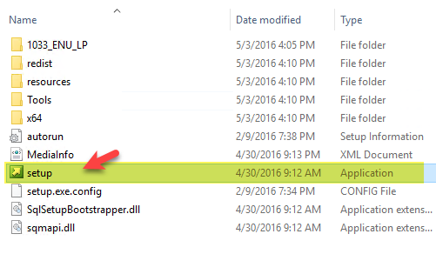

1. In the **User Account Control** dialog box, click **Yes**.
2. In the **SQL Server Installation Center** dialog box, review the options available.

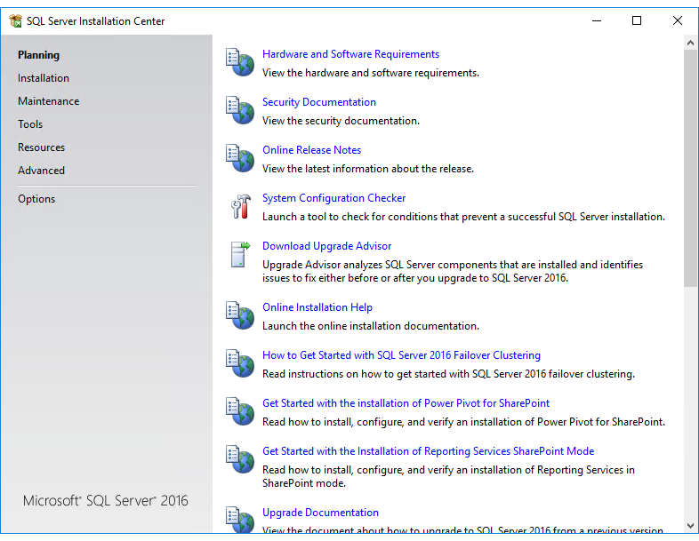

1. Navigate to the pane on the left and click **Installation**.
2. Click the link for a **New SQL Server stand-alone installation or add features to an existing installation**.

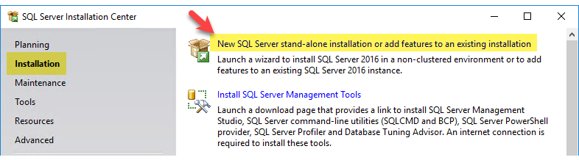

1. In the **Microsoft Update** dialog box, click **Next**.

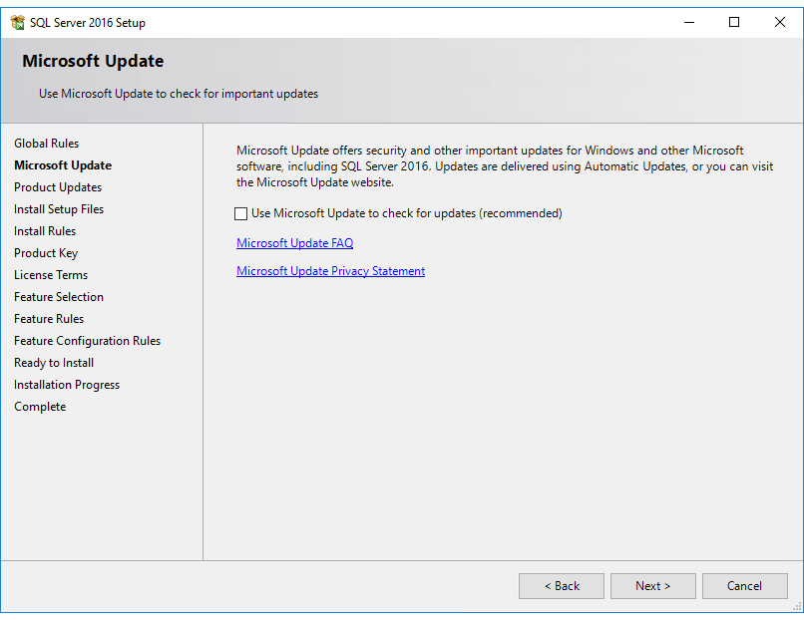

1. When the **Install Rules** dialog box opens, ignore the **Computer domain controller Warning**, then click **Next**.

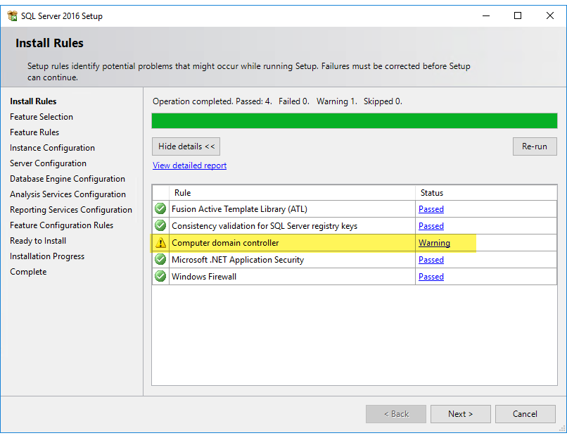

1. In the **Product Key** dialog box, verify **Evaluation** is selected, then click **Next**.

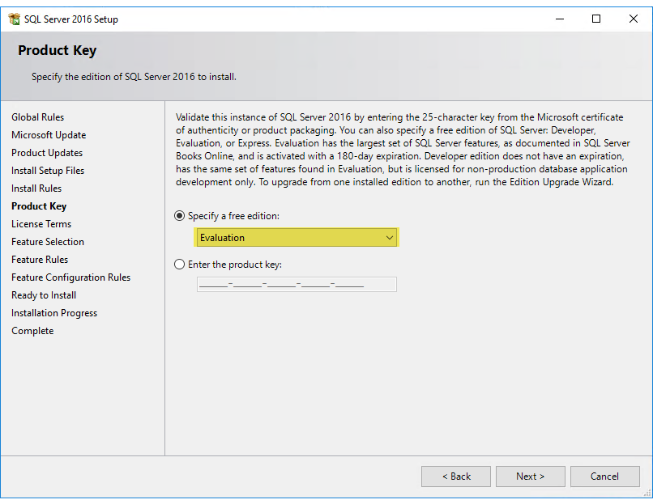

1. In the **License Terms** dialog box, place a check in the **I accept the license terms** check box and click **Next**.
2. In the **Feature Selection** dialog box, place a check in the following check boxes:
   * Database Engine Services
   * Analysis Services
   * Reporting Services – Native
   * Reporting Services – SharePoint
   * Reporting Services Add-in for SharePoint Products
   * Client Tools Connectivity
   * Integration Services

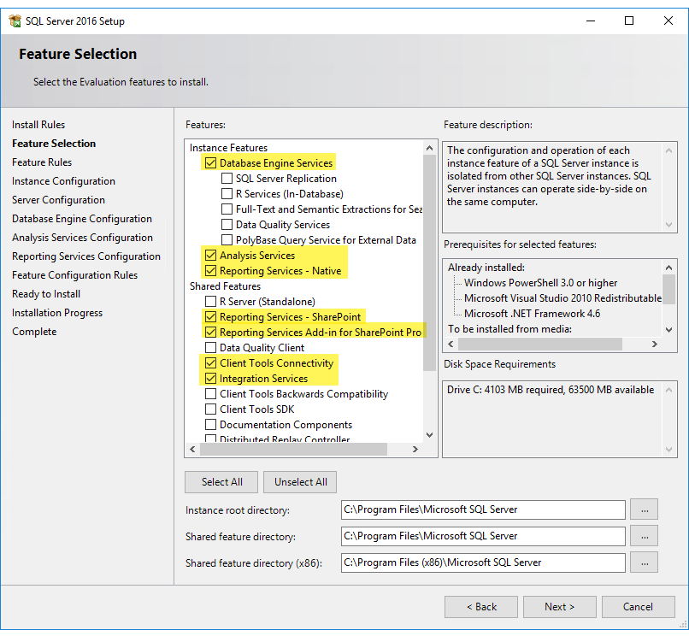

1. Click **Next**.
2. In the **Instance Configuration** dialog box, leave the **Default instance** settings as they are, and click **Next**.

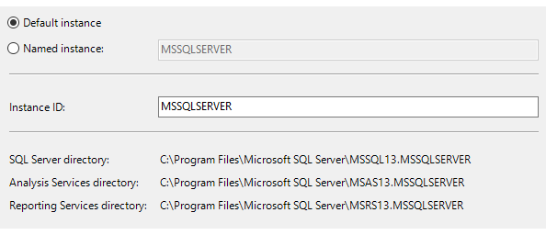

1. In the **Server Configuration** dialog box, move to the **SQL Server Analysis Services** row, click into the empty **Password** text box and enter Passw0rd.

*In Passw0rd, the 0 is numeric.*

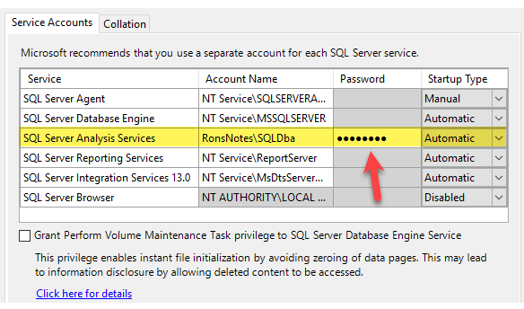

1. Click **Next**.
2. In the **Database Engine Configuration** dialog box, review the current settings.
3. Click **Add Current User**.
4. Notice you now see **RONSNOTES\Student (Student)** listed in the **Specify SQL Server administrators** text box.
5. Click **Add…**.
6. In the **Select Users, Computers, Service Accounts, or Groups** dialog box, move to the **Enter the object names to select** text box and enter SQLDba.

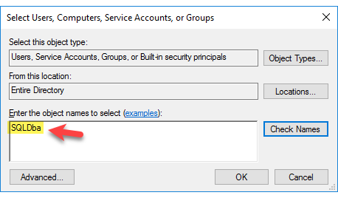

1. Click **Check Names** and notice **SQLDba** is now underlined.
2. Click **OK**.
3. Notice you now see **RONSNOTES\SQLDba (SQLDba)** listed in the **Specify SQL Server administrators** text box.

*At this point you should show two administrators:*

* *RONSNOTES\Student (Student)*
* *RONSNOTES\SQLDba (SQLDba)*

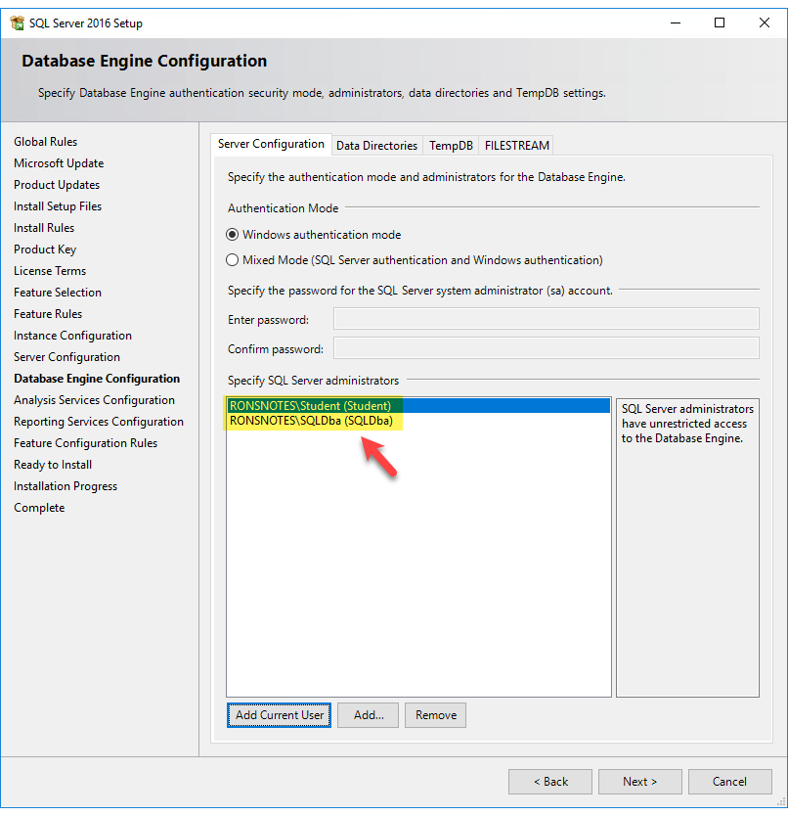

1. Click **Next**.
2. In the **Analysis Service Configuration** dialog box, review the current settings.
3. Click **Add Current User**.
4. Notice you now see **RONSNOTES\Student (Student)** listed in the **Specify which users have administrative permissions for Analysis Services** text box.
5. Click **Add…**.
6. In the **Select Users, Computers, Service Accounts, or Groups** dialog box, move to the **Enter the object names to select** text box and enter SQLDba.
7. Click **Check Names** and notice **SQLDba** is now underlined.
8. Click **OK**.
9. Notice you now see **RONSNOTES\SQLDba (SQLDba)** listed in the **Specify which users have administrative permissions for Analysis Services** text box.

*At this point you should show two administrators:*

* *RONSNOTES\Student (Student)*
* *RONSNOTES\SQLDba (SQLDba)*

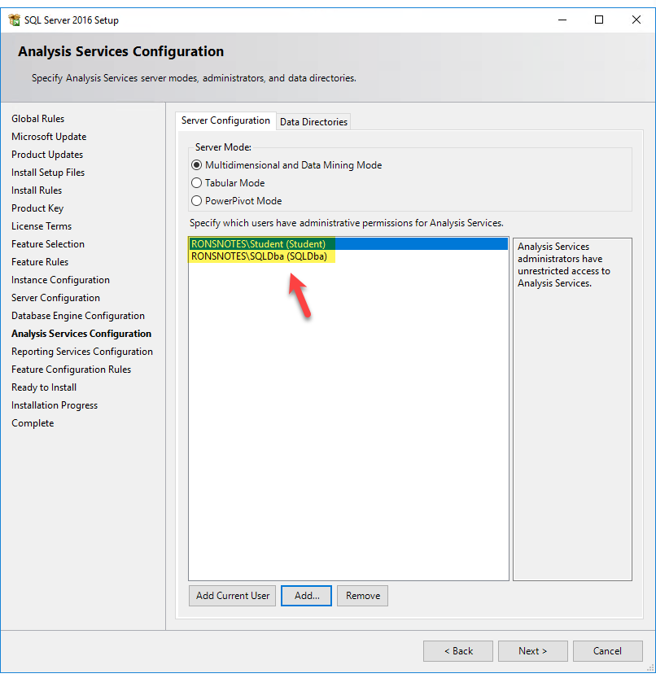

1. Click **Next**.
2. In the **Reporting Services Configuration** dialog box, move to the **Reporting Services Native Mode** section, and click the radio button to **Install only**.

*Optional: you can leave the settings as they are (default) if you plan to configure Reporting Services in Native mode.*

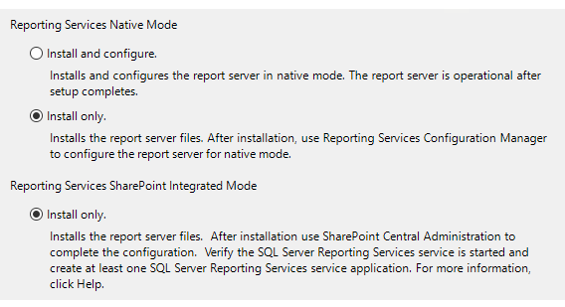

1. Click **Next**.
2. In the **Ready to Install** dialog box, click **Install**.
3. Upon **Success**, click **Close**.

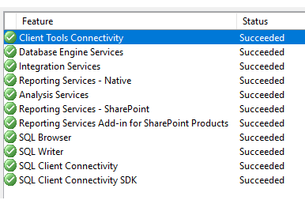

#### Task: Install SQL Server Management Studio

*There is no PowerShell script equivalent to this task.*

1. Switch to **Server Manager**.
2. Navigate to the pane on the left and click to select the **Local Server** tab.
3. Locate the **IE Enhanced Security Configuration** setting and click the corresponding **On** link.

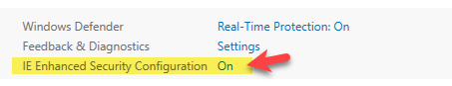

1. Click the **Off** radio button for both **Administrators** and **Users**.

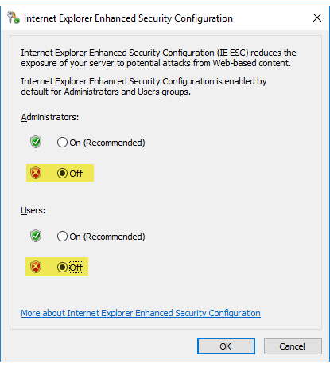

1. Click **OK**.
2. Switch back to the **SQL Server Installation Center**, move to the pane on the left and click **Installation**.
3. Click **Install SQL Server Management Tools** link.

*If you receive the Internet Explorer settings dialog box, move the radio button to Don’t use recommended settings and click OK.*

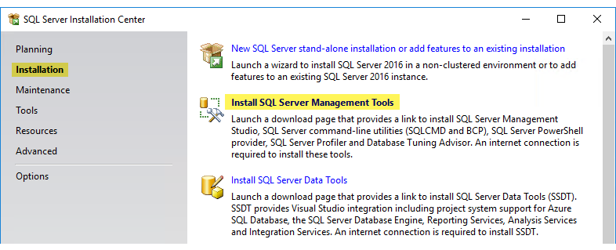

1. Click the **Download SQL Server Management Studio** (**Current GA release for production use**) link.

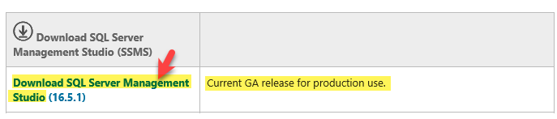

1. In the prompt below asking **Do you want to run or save SSMS-Setup-ENU.exe**, click **Save** (just in case).
2. Wait for the download to complete.
3. Once the download completes, move to the **SSMS-Setup-ENU.exe** **download has completed** prompt, and click **Run**.
4. In the **Welcome** dialog box, review the information, then click **Install**.

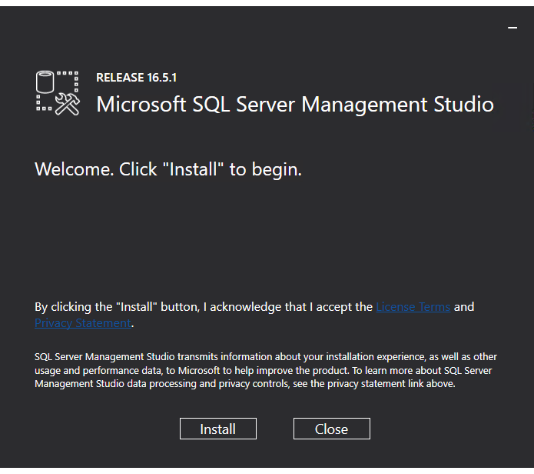

1. Once the installation completes, click **Close**.

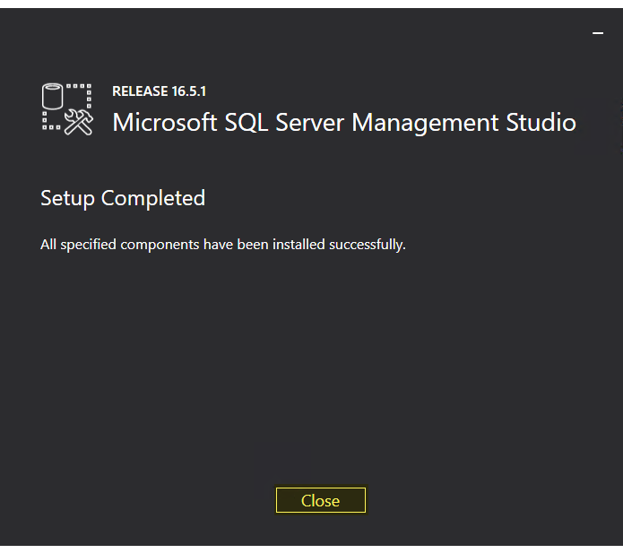

1. At this point we need to reboot the virtual machine. Switch to **Hyper-V Manager**, right-click **Humongous** virtual machine and click **Shut Down…**.
2. In the dialog box asking **Are you sure you want to shut down the operating system in the selected virtual machine(s)**, click **Shut Down**.
3. Again, right-click **Humongous** virtual machine, then click **Start**.
4. When the virtual machine comes back up, click **Other user** in the lower-left corner, then log in as **Student**.
5. Press the **Windows** key, then enter SQL.
6. Right-click **Microsoft SQL Server Management Studio**, then click **Pin to taskbar**.
7. Press **Esc** to return to desktop view.
8. Right-click the **Microsoft SQL Server Management Studio** icon in the taskbar, right-click the new **SQL Server Management Studio** icon showing, and click **Run as administrator**.

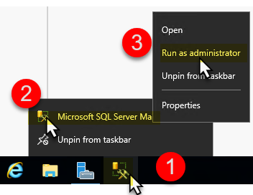

1. In the **User Account Control** dialog box, click **Yes**.
2. In the **Connect to Server** dialog box, review the current settings, then click **Connect**.

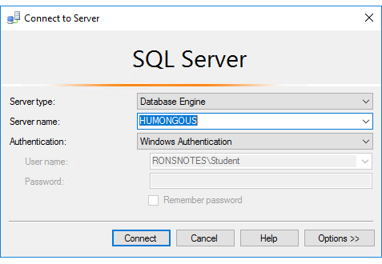

1. In the **Object Explorer** pane on the left, right-click on the server name at the top and click **Properties**.

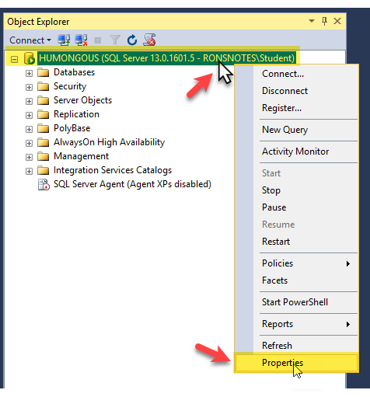

1. In the **Server Properties – HUMONGOUS** dialog box, move to the pane on the left and click **Advanced**.

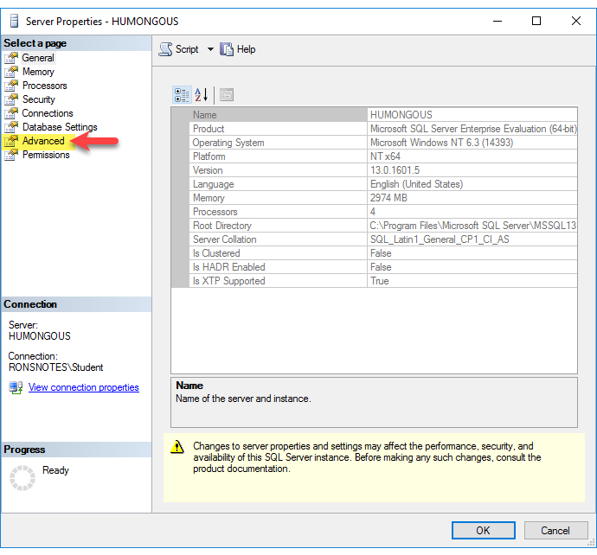

1. Scroll down to the **Parallelism** section, then change the **Max Degree of Parallelism** value from **0** to 1. *(This is required for SharePoint 2016).*

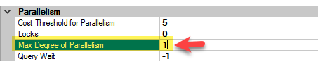

1. Click **OK**.
2. Navigate back to **Object Explorer** pane on the left and expand **Security** folder.
3. Right-click **Logins** and click **New Login…**.

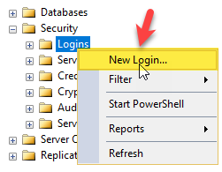

1. In the **Login - New** dialog box, click **Search…**.

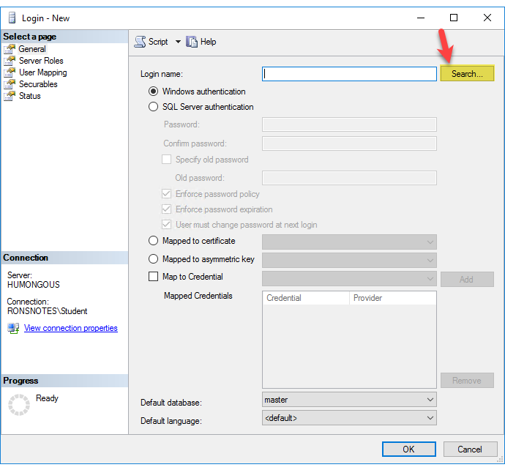

1. In the **Select User, Service Account, or Group** dialog box, click **Advanced…**.

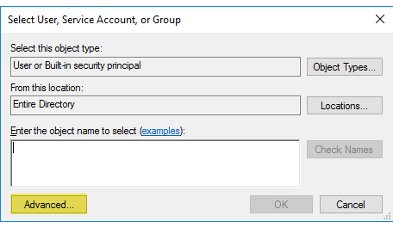

1. Click **Locations…**.

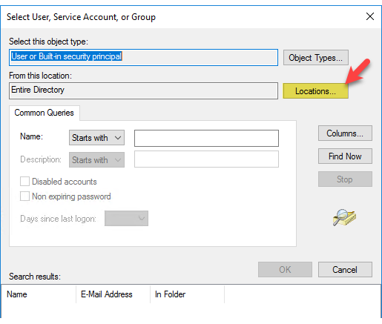

1. In the **Locations** dialog box, verify **Entire Directory** is selected, then click **OK**.

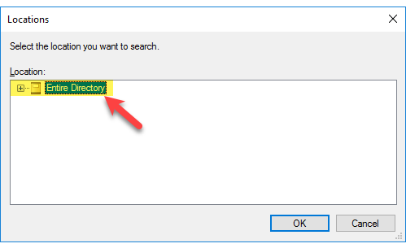

1. In the **Select User, Service Account, or Group** dialog box, move to the **Starts with** setting and enter SVC_Farm into the corresponding text box.

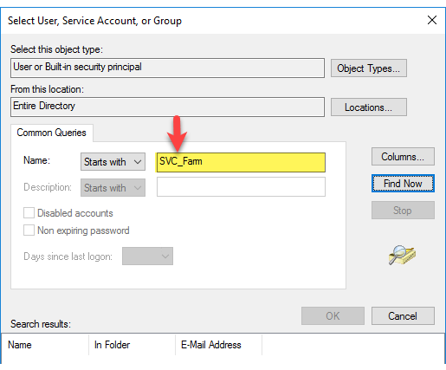

1. Click **Find Now**.
2. Notice you now see **SVC_Farm** listed below in the **Search results**.

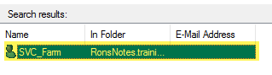

1. Click **OK**.
2. Back in the **Select User, Service Account, or Group** dialog box, review the results.

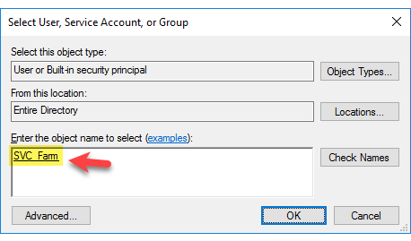

1. Click **OK**.
2. Back in the **Login – New** dialog box, review the results, then click **OK**.

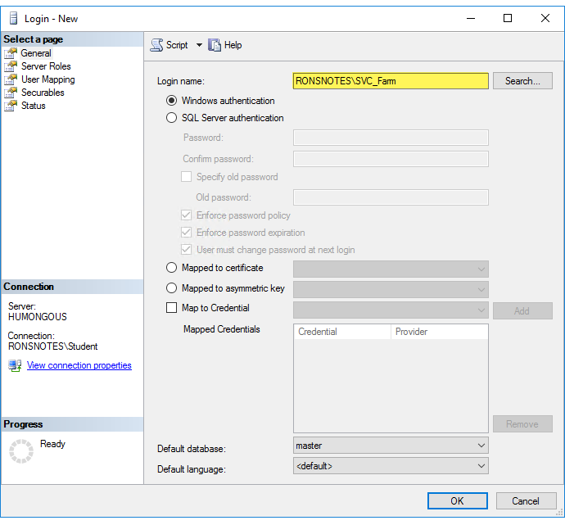

1. Repeat the prior twelve steps to create a login for **SVC_Installation**.

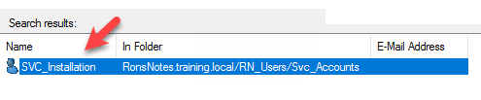

1. Move back to the **Object Explorer** pane on the left and expand **Logins** folder.
2. Right-click **RONSNOTES\SVC_Farm** and click **Properties**.

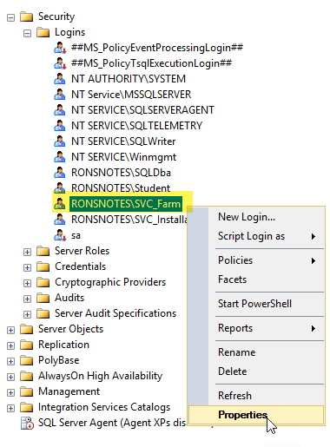

1. When the **Login Properties – RONSNOTES\SVC_Farm** dialog box opens, review the settings and options available.
2. Move to the pane on the left and click **Server Roles**.
3. Navigate to the **Server roles** setting and place a check in both the **dbcreator** and **securityadmin** check boxes.

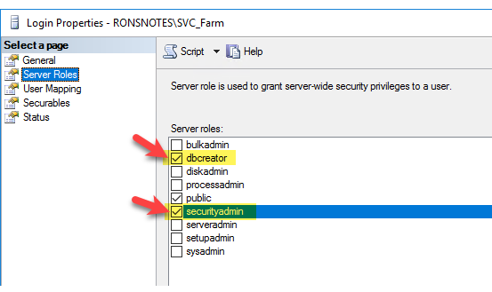

1. Click **OK**.
2. Repeat the last five steps for **SVC_Installation**.

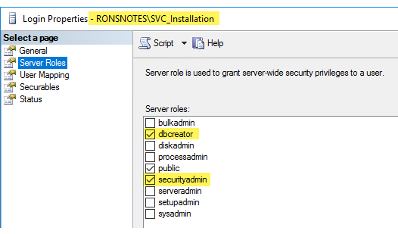

1. Close **SSMS**.
2. Restart the virtual machine.
3. When the virtual machine comes back up, log on as **Student**.

## Phase 05 Setup SharePoint Farm

### Phase Objective

In this phase, we will setup SharePoint on the Humongous virtual machine.

### Phase Topics

* Setup SharePoint Server Humongous

### Task: Setup SharePoint Server Humongous

*There is no PowerShell script equivalent to this task.*

1. In **Hyper-V Manager**, double-click the **Humongous** virtual machine, then click **Connect**.
2. At the logon screen, click **Other user** in the lower-left corner, then log in as **Student**.
3. Start **File Explorer**.
4. Navigate to the pane on the left and click to select **This PC**.



1. Double-click **C:\** drive.
2. Click to select **officeserver**, then right-click the same file and click **Mount**.

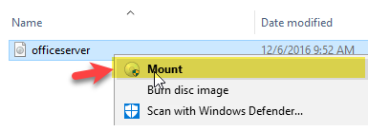

1. When the list of files appears, review the list.
2. Locate and double-click **prerequisiteinstaller**.



1. In the **User Account Control** dialog box, click **Yes**.
2. In the **Welcome to the Microsoft SharePoint 2016 Products Preparation Tool** dialog box, review the information, then click **Next**.

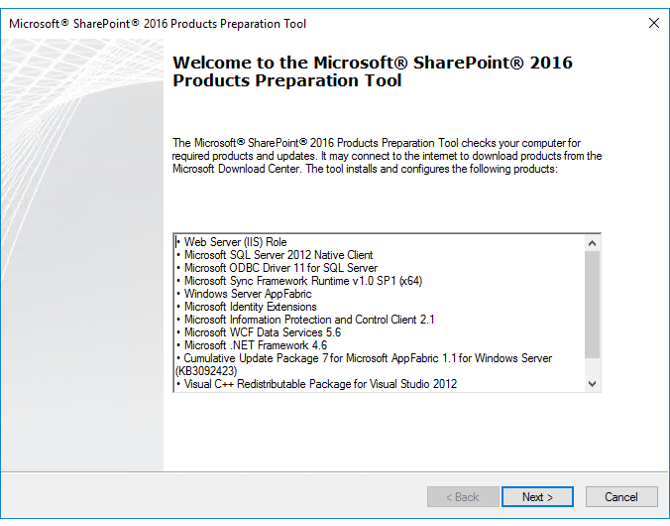

1. In the **License Terms for software products** dialog box, place a check in the **I accept the terms of the License Agreement(s)** check box, then click **Next**.
   * *This is long running.*
2. When prompted, click **Finish** and the virtual machine will restart.

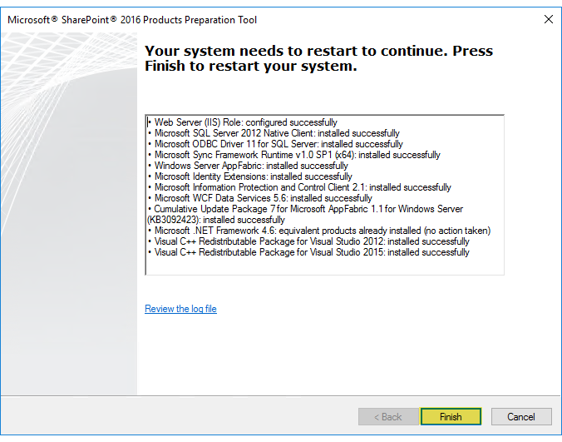

1. Log in as **Student**.
2. Wait for the **F:\prerequisiteinstaller.exe** error window, then click **OK**.

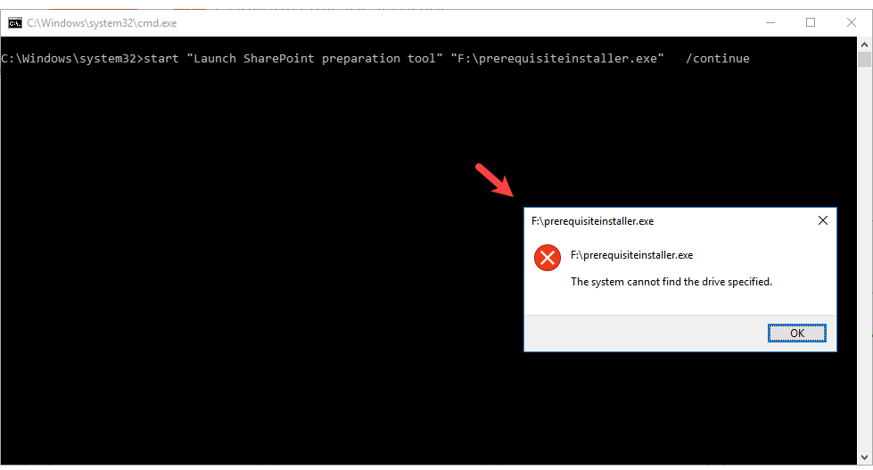

1. Repeat steps **4-11** to rerun the **prerequisiteinstaller**, and it will complete the installation.
2. In the **Installation Complete** dialog box, click **Finish**.

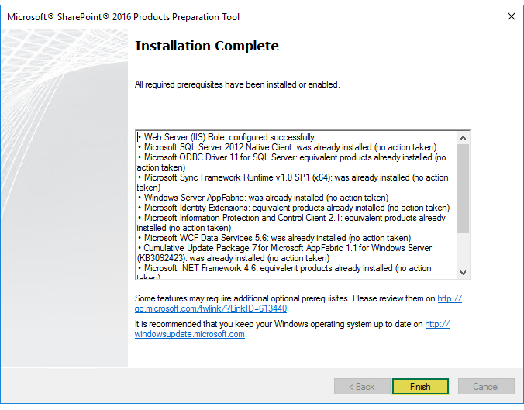

1. Back in **File Explorer**, viewing the mounted **officeserver** files, double-click **setup** (red icon).



1. In the **User Account Control** dialog box, click **Yes**.
2. In the **Enter your Product Key** dialog box, you will enter the product key. All evaluation copies have the same key.
   * NQGJR-63HC8-XCRQH-MYVCH-3J3QR
3. Click **Continue**.
4. In the **Read the Microsoft Software License Terms** dialog box, place a check in the **I accept the terms of this agreement** check box, and click **Continue**.
5. In the **Choose a file location** dialog box, review the current settings, then click **Install Now**.

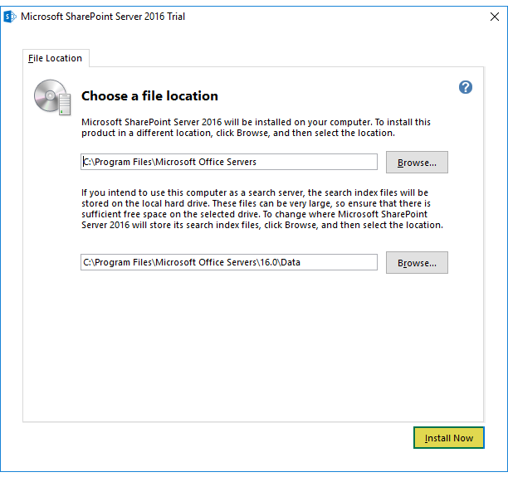

1. Upon completion (**and remember Humongous is first**), leave the check in **Run the SharePoint Products Configuration Wizard now** check box, and click **Close**.

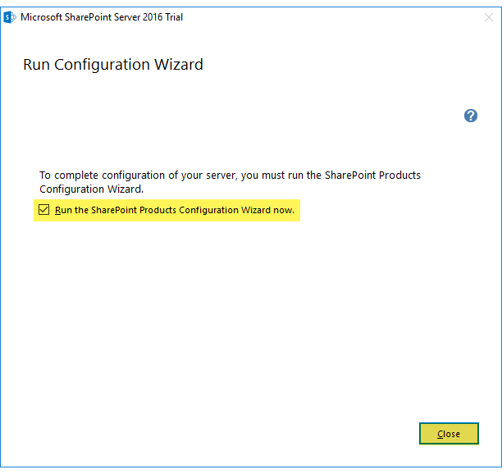

1. In the **Welcome to SharePoint Products** dialog box, review the information, then click **Next**.

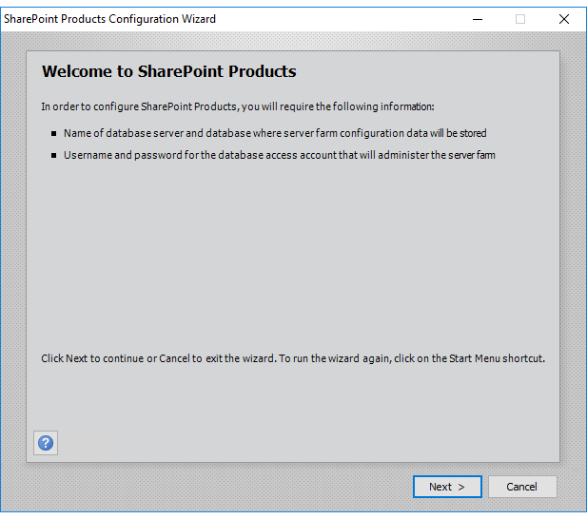

1. In the **SharePoint Products Configuration Wizard** dialog box advising **The following services may have to be started or reset during configuration**, click **Yes**.

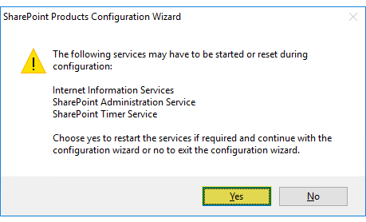

1. In the **Connect to a server farm** dialog box, move the radio button to **Create a new server farm**, then click **Next**.

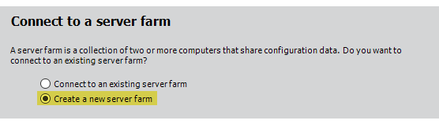

1. In the **Specify Configuration Database Settings** dialog box, navigate to the **Database server** setting and enter Humongous into the corresponding text box.
2. Move to the **Username** text box below and enter SVC_Installation.
3. In the **Password** text box, enter Passw0rd.

*In Passw0rd the 0 is numeric.*

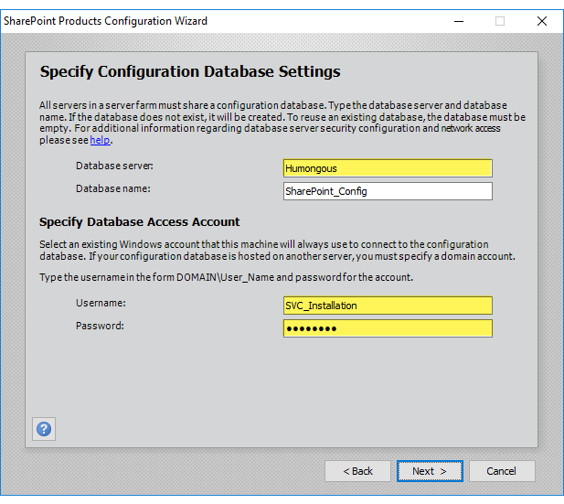

1. Click **Next**.
2. In the **Specify Farm Security Settings** dialog box, move to the **Passphrase** text box and enter Passw0rd.

*In Passw0rd the 0 is numeric.*

1. In the **Confirm passphrase** text box, confirm the passphrase, then click **Next**.

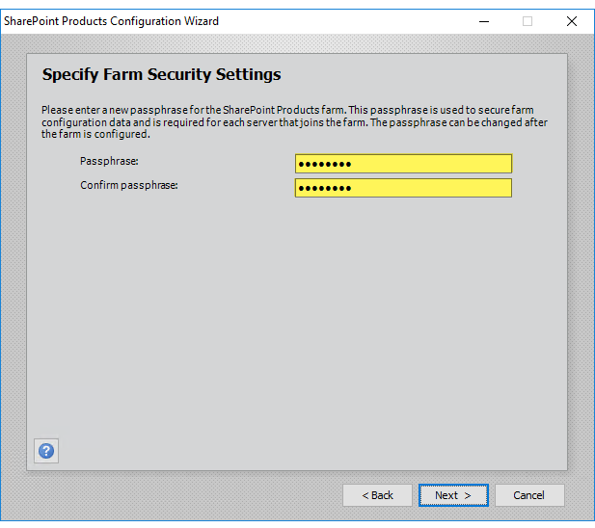

1. In the **Specify Server Role** dialog box, *(since we are working on Humongous virtual machine)* click to select the **Single-Server Farm** radio button.

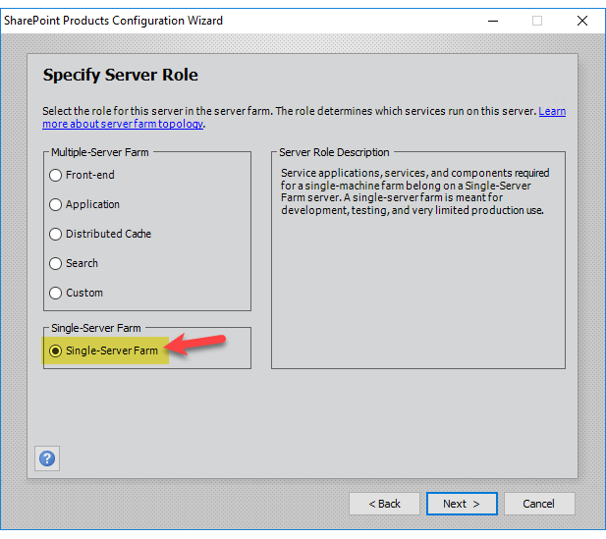

1. Click **Next**.
2. In the **Configure SharePoint Central Administration Web Application** dialog box, place a check in the **Specify port number** check box.
3. Move to the corresponding text box and change the port to 17660. *(My old employee number from back in the day)*, then click **Next**.

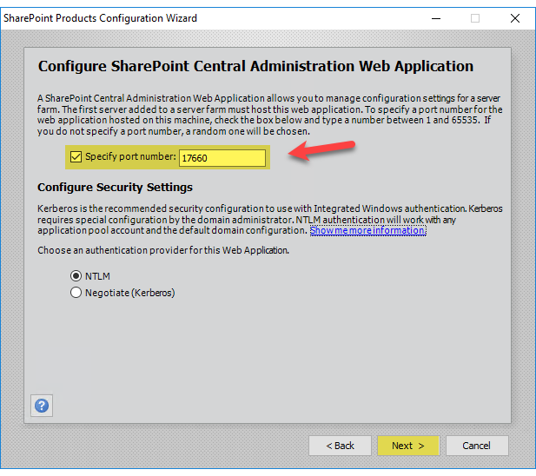

1. In the **Completing the SharePoint Products Configuration Wizard** dialog box, review the settings, then click **Next**.

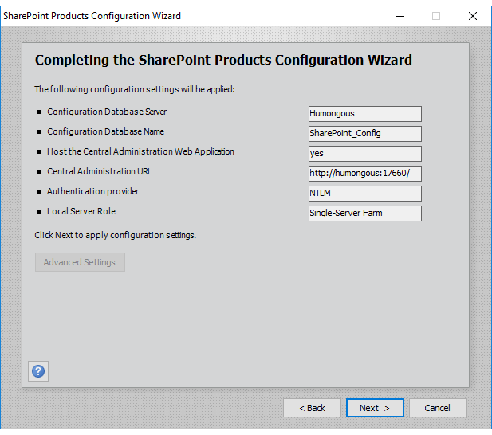

1. In the **Configuration Successful** dialog box, review the settings, then click **Finish**.

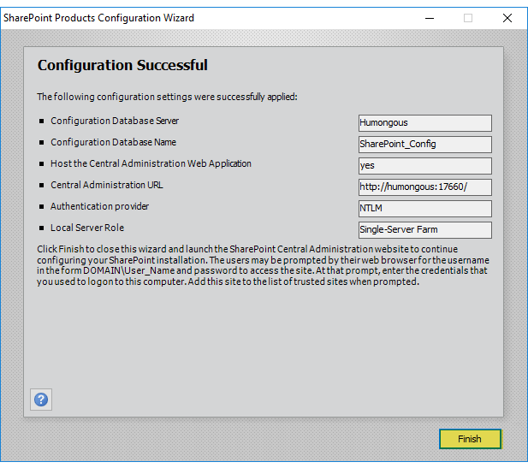

1. In the **Help Make SharePoint Better** dialog box, click to select the **No, I don’t wish to participate** radio button, then click **OK**.

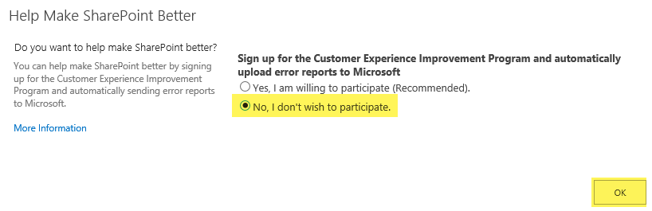

1. On the **Welcome** page, move to the **Yes, walk me through the configuration of my farm using this wizard** setting and click the corresponding **Start the Wizard**.

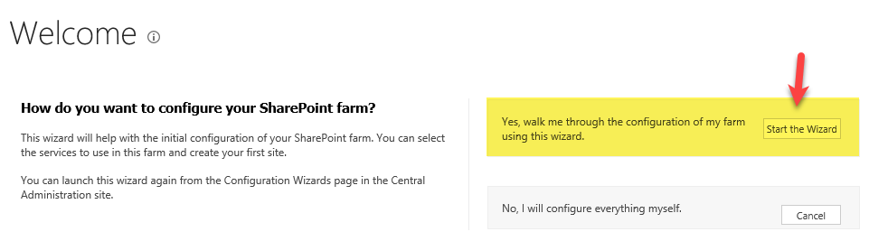

1. On the **Service Applications and Services** page, navigate to the **Create new managed account** setting, move to the **User name** text box and enter RonsNotes\SVC_Farm.
2. In the **Password** text box, enter Passw0rd.

*In Passw0rd the 0 is numeric.*

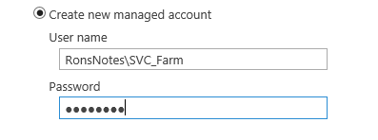

1. Click **Next**. This will take a few to configure.

*Upon completion, you may see an error about the Search Service Application which you can ignore. Click Next.*

1. In the **Create Site Collection** dialog box, move to the **Title** text box and enter <your name> Team Site *(i.e. Ron’s Team Site)*.

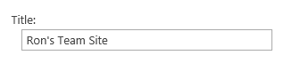

1. Click **OK**.
2. In the **This Completes the Farm Configuration Wizard** page, review the information given.
3. Right-click a blank spot above the page (in Internet Explorer above the address bar) and click **Menu bar**.
4. Navigate to the menu bar, click **Favorites**, and then click **Add to favorites…**.
5. In the **Add a Favorite** dialog box, click **Add**.

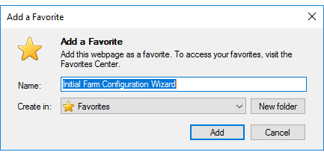

1. Move to the **Site URL** link, and click the corresponding link.

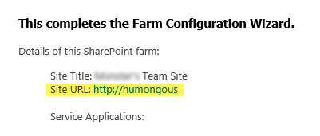

1. When **Team Site** opens, review the options available.
2. Navigate to the menu bar, click **Favorites**, and then click **Add to favorites…**.
3. In the **Add a Favorite** dialog box, click **Add**.
4. Click the back button and then click **Finish** in the **This completes the Farm Configuration Wizard** dialog box.
5. When **Central Administration** opens, review the page and the options available.

You have now created a humongous single-server farm.